Table of Content

**Case study 1 - Learning Link Foundation (Keyword: Operational Excellence) 3**

Quick Facts 3

Summary 3

Full Case Study 4

Tools Logo to add 8

**Case study 2 - Farmers for Forest (Keyword: Impact Measurement) 8**

Quick Facts 8

Summary 8

Full Case Study 10

Tools Logo to add 13

**Case study 3 - I-Saksham (Keyword: Leadership Development) 13**

Quick facts 13

Summary 14

Full Case Study 15

Tools Logo to add 19

**Case study 4 - Vipla Foundation (Keyword: Early Childhood Edtech) 19**

Quick Facts 20

Summary 20

Full Case Study 21

Tools logo to add 24

**Case Study 5 - Akshay Patra (Keyword:Supply Chain Optimization) 25**

Quick Facts 25

Summary 25

Full Case Study 26

Tools Logo to add 30

**Case Study 6 - Anudip (Keyword:Digital Skilling & Employability) 30**

Quick Facts 30

Summary 31

Full Case Study 32

**Case Study 7 - Lend a Hand India (Keyword:Vocational Education Digitization) 40**

Quick Facts 40

Summary 40

Full Case Study 41

Tools to add 44

**Case Study 8 - FMCH (Keyword:Public Health Program Delivery) 45**

Quick Facts 45

Summary 45

Full Case study 46

Tools to add 47

**Case Study 9: Educate Girls (Keyword: Precision Targeting) 54**

Quick Facts 54

Summary 55

Full case study 56

Tools to add 60

**Case Study 10: Educate Girls (Keyword: Operational Excellence) 61**

Quick Facts 61

Summary 61

Full Case study 62

**Case Study 11: ARMMAN 66**

Quick Facts 66

Summary 67

Full Case study 68

Snapshots 70

# Case study 1 - Learning Link Foundation (Keyword: Operational Excellence)

**Thumbnail Header: Tech Integration Scales Field Operations**

**Header-** Strategic Platform Adoption Enables LLF to Centralize Over 160 Projects and Drive Unprecedented Operational Scale Across India

## **Quick Facts**

|  |  |
| --- | --- |
| **Category** | **Details** |
| **Organisation Name** | Learning Links Foundation |
| **Organisation Website Link** | [https://www.learninglinksindia.org](https://www.learninglinksindia.org/) |
| **Founding Year** | 2002 |
| **Number of Beneficiaries served** | Over 17.8 million students and 2.2 million teachers across 52,000+ schools |
| **Geography Served** | Pan India |
| **Focus Area** | * Programmatic Impact * Operational Efficiency * Capacity Development |
| **Functions Impacted** | *Program & Project Management, Procurement, Budgeting, Grant* Management*, Compliance, Reporting, IT Support, and HR* |
| **SDG Alignment** | Quality Education (SDG 4), Gender Equality (SDG 5), Decent Work and Economic Growth (SDG 8), Reduced Inequalities (SDG 10) |

## **Summary**

**Impact Numbers**

* **90% Data Accuracy**
* **50% Faster Processes**
* **160+ Projects Centralized**

**About the Organisation**

Learning Links Foundation (LLF) is a non-profit organization working to strengthen both formal and non-formal education in India. Through its programs in technology integration, teacher training, policy research, and skill development, LLF promotes lifelong learning. LLF works closely with the Ministries of HRD and IT, State Governments, SCERTs, universities, private schools, and apex bodies like NCERT, NUEPA, NCTE, NAAC, and others. It also partners with multilaterals, NGOs, and civil society actors to implement transformative programs across India.

Operating across 21 states, LLF has reached over 17.8 million students and 2.2 million teachers, transforming 52,000+ schools since its inception.

**Problem Statement**

LLF faced major operational challenges due to fragmented data, manual processes, and lack of real-time visibility. These issues led to data silos, inefficiencies, delayed reporting, and poor data quality, limiting scalability, impact measurement, and timely decision-making

**Solution**

LLF embarked on a comprehensive digital transformation initiative, by adopting **Salesforce** as its core operational backbone. This included centralizing data, automating key workflows (procurement, budgeting, compliance), and enabling real-time insights through custom dashboards. A hybrid team, combining internal project management expertise with external Salesforce implementation partners ensured a tailored, well-managed rollout.

**Learnings**

* Investing in change management and training is critical for successful tech adoption.
* Phased implementation reduces disruption and supports iterative learning.
* Internal champions help accelerate user adoption and institutional ownership.

**Key Technologies Used**

* Salesforce CRM
* Salesforce Dashboards & Analytics
* API Integrations (e.g., with Tally)
* Mobile/Web User Interfaces
* Generative AI for Knowledge Management

## **Full Case Study**

**Challenge**

**Fragmented data systems and manual processes severely limited LLF’s ability to scale, ensure compliance, and deliver timely impact across its programs.**

Learning Links Foundation (LLF), managing an expansive and growing portfolio of education and skilling programs, contended with significant operational inefficiencies rooted in fragmented data management, manual processes, and a critical absence of real-time operational visibility.

Prior to its digital transformation, LLF's reliance on disparate spreadsheets and manual workflows for program data, procurement, budgeting, donor reporting, and compliance led to:

* Data Silos and Inconsistency: Information was fragmented across departments, resulting in duplication of effort and frequent data errors.
* Operational Inefficiencies: Delayed reporting, inconsistent data quality, and a lack of real-time insight into project status or resource utilization became unmanageable as the organization scaled to over 160 live projects across multiple states.
* Hindered Program Scaling: Difficulty in tracking granular beneficiary outcomes (student progress, teacher engagement, resource distribution) led to missed intervention opportunities. Non-standardized processes made scaling successful programs challenging.
* Compliance Risks: Critical documents were scattered across various locations and formats, increasing the risk of audit issues and regulatory non-compliance.
* Impaired Decision-Making: These inefficiencies hampered internal decision-making and made it difficult to provide timely, accurate updates to donors and partners, jeopardizing funding and trust.

The magnitude of these challenges directly threatened LLF’s capacity to deliver high-quality programs at scale, limited operational efficiency, and undermined stakeholder credibility, underscoring the urgent need for a robust digital solution to centralize data, automate workflows, and enable evidence-based decision-making.

**Solution**

**LLF centralized program data and automated workflows on Salesforce, boosting efficiency and decision-making**

LLF's digital transformation journey was a strategic, multi-phase initiative focused on building a scalable and efficient operational backbone leveraging Salesforce.

**Phase 1: Strategic Prioritization & Core Platform Selection**

* **Problem-First Approach:** The initial focus was on addressing the most critical operational bottlenecks: fragmented program management, inefficient procurement and budgeting, and the absence of centralized, real-time data. These areas were prioritized for their direct impact on program scaling, compliance, and donor accountability.
* **Salesforce Selection:** After a rigorous assessment, Salesforce was chosen as the foundational platform. Its flexibility, scalability, and features for non-profits (grant tracking, program management, donor relations, procurement, analytics) were key differentiators, along with its strong API capabilities for integration.

**Phase 2: Hybrid Implementation & Customization**

* **Blended Team Model:** LLF adopted a hybrid implementation model, combining an internal project management team with an external Salesforce implementation partner. This approach ensured deep contextual understanding, efficient knowledge transfer, and access to specialized technical expertise.
* **Off-the-Shelf Customization:** Instead of building from scratch, LLF customized off-the-shelf Salesforce modules. This accelerated deployment while allowing for extensive tailoring in critical areas such as:
  + Grant process tracking and management
  + Detailed project activity and beneficiary tracking
  + Automated procurement and budget approval workflows
  + Comprehensive compliance documentation and asset management
  + Integrated helpdesk ticketing
* **Workflow Automation:** Custom dashboards and automated workflows were developed to streamline reporting, enforce approvals, and enable real-time monitoring of key performance indicators. Integration with financial systems like Tally was crucial for seamless data flow.

**Phase 3: Phased Rollout & Sustainable Adoption**

* **Iterative Deployment:** The implementation was phased to manage change effectively and minimize disruption across LLF's widespread operations. Core modules were deployed first, followed by successive rollouts of more specialized functionalities.
* **Robust Change Management:** A critical investment was made in comprehensive change management. This included extensive user training sessions, development of user manuals, and continuous support mechanisms to address user queries and resistance.
* **Champion Network:** Key individuals within teams were identified and empowered as "digital champions" to drive adoption and provide peer support, ensuring smooth integration of the new tools into daily operations.

**Funding & Strategic Evolution:**

* Funding for this significant transformation was secured through a combination of internal resources and strategic support from key donors who recognized the long-term value and necessity of digital advancement. Beyond financial aid, some partners provided invaluable technical mentorship and access to best practices.
* Over time, the Salesforce implementation evolved from a back-office efficiency initiative into a strategic enabler, providing a scalable digital foundation for LLF’s continued growth and innovation in program delivery and impact measurement.

**Outcome & Impact**

**LLF achieved accelerated reporting, enhanced compliance, and data-driven agility, successfully scaling programs across 160+ projects..**

LLF's digital transformation, powered by Salesforce, has fundamentally redefined its operational capabilities and amplified its impact, delivering measurable improvements for both internal teams and external stakeholders. Key achievements include:

* **Operational Efficiency**: Automated approval workflows reduced processing times by up to 50%. Staff time previously spent on manual data entry and follow-ups is now directed toward strategic tasks and fieldwork.
* **Data Accuracy & Speed**: Internal audits post-implementation confirmed over 90% data accuracy, and reporting timelines dropped from weeks to just a few hours.
* **Program Scale**: The centralized system now supports 160+ live projects across 21 states, with seamless documentation and reporting supporting scale and compliance.
* **Decision-Making**: Custom dashboards and generative AI tools democratized access to insights. Program managers and leadership can now track metrics like beneficiary reach, funding utilization, or project delays through simple queries.
* **Funders & Stakeholders**: LLF’s enhanced ability to provide real-time, data-driven updates has strengthened trust with funders, government partners, and donors. This has also opened doors to new funding partnerships.

Moreover, the organization has embraced a data-driven culture. Regular digital upskilling sessions have strengthened internal capacities, and teams increasingly rely on evidence and metrics to guide planning, resource allocation, and monitoring.

A standout innovation is the use of generative AI within Salesforce’s knowledge management ecosystem. This enables even non-technical users to interact with data intuitively. For example, a field coordinator can now ask, “Which schools in Uttar Pradesh saw an improvement in student engagement last quarter?” and receive a data-rich response instantly, an interaction that previously would have taken hours of collating reports.

In essence, LLF’s transformation has shifted it from being operationally reactive to proactively strategic. The investment in technology has paid off not only in efficiency and credibility but also in positioning LLF as a digitally mature leader in the Indian social sector.

**Additional Media -**

<https://drive.google.com/drive/folders/1McsQxGuwW-2nyEzjjpshXYMG0s0eSuC9?usp=drive_link>

## **Tools Logo to add**

Salesforce

# **Case study 2 - Farmers for Forest (Keyword: Impact Measurement)**

**Thumbnail Header:** Smart Stack Enables Agroforestry Scale

**Header -** F4F's Hybrid Tech Stack Revolutionizes Agroforestry Monitoring and Programmatic Scale

## **Quick Facts**

|  |  |
| --- | --- |
| **Category** | **Details** |
| **Organisation Name** | Farmers for Forests |
| **Organisation Website Link** | www.farmersforforests.org |
| **Founding Year** | December 2019 |
| **Number of Beneficiaries served** | *25,000* |
| **Geography Served** | *Maharashtra, Gujarat, Karnataka, Jharkhand, Chennai* |
| **Focus Area** | * Programmatic Impact * Operational Efficiency |
| **Functions Impacted** | Program Delivery / Beneficiary Services  Monitoring, Evaluation & Learning (MEL)  Internal Functions: Donor Reporting, Carbon Estimation, and GIS Mapping |
| **SDG Alignment** | * SDG 13: Climate Action * SDG 15: Life on Land * SDG 1: No Poverty * SDG 8: Decent Work and Economic Growth |

## **Summary**

**Impact Highlights**

* **90%+ Data Accuracy**.
* **10X Faster Monitoring**
* **5-State Expansion**

**About Farmers for Forests**

Founded in December 2019, Farmers for Forests (F4F) is a pioneering organization dedicated to fostering climate resilience and sustainable livelihoods through tech-enabled agroforestry. Operating across Maharashtra, Gujarat, Karnataka, Jharkhand, and Chennai, F4F empowers smallholder farmers to restore degraded land, enhance biodiversity, and generate verifiable ecosystem services.

**Problem Statement**

F4F struggled to accurately monitor its remote agroforestry projects, and lacked integrated systems for farmer data, project tracking, and donor reporting—limiting its ability to scale and demonstrate credible impact for carbon credit generation and funder reporting.

**Solution**

F4F prioritized tech-enabled monitoring and verification, deploying a hybrid suite of open-source GIS tools, AI-based drone imagery analysis, and integrated off-the-shelf platforms. This enabled accurate, scalable monitoring of tree survival and growth, streamlining internal operations and enhancing stakeholder reporting, all while building strong internal tech capacity.

**Learnings**

* **Solve High-Stakes Bottlenecks First:** Prioritizing critical challenges like impact monitoring builds immediate credibility and unlocks catalytic growth.
* **Build Internal Tech Agility:** In-house technical capacity drives rapid, field-aligned innovation and sustained digital transformation.
* **Drive Adoption Through Champions:** User-centric piloting and internal advocates are crucial for seamless technology integration and broad team buy-in.

**Key Technologies**

* Open-source GIS tools (QGIS, Google Earth Engine)
* Drone Orthomosaics
* AI-based Tree Detection (DeepForest, Detectron2)
* Zoho CRM (Donor/Project Management)
* KoBo Toolbox (Field Data Collection)
* Google Workspace (Internal Collaboration)
* Custom Admin Panel (React/PHP/MySQL)

## **Full Case Study**

**Challenge**

**Inconsistent data and fragmented operations constrained F4F's ability to scale impact and ensure program fidelity across remote agroforestry projects.**

Farmers for Forests (F4F) confronted two critical, interconnected challenges that threatened its core mission and scalability:

1. **Inaccurate and Unscalable Monitoring:**
   * Manual field surveys to track tree survival were time-consuming, error-prone, and inconsistent—especially across vast, remote areas. This undermined F4F’s ability to produce credible, verifiable data, jeopardizing access to carbon credits and limiting its ability to meet funder reporting standards.
2. **Lack of Integrated Operational Systems:**
   * With no integrated digital infrastructure, F4F relied on disconnected, manual processes to manage farmer records, project timelines, and donor engagement. As operations expanded from one district to five states, these inefficiencies severely strained capacity and risked operational breakdown.

These challenges severely impacted F4F's operational efficiency, limiting its ability to onboard new farmers quickly, provide timely support, and verify environmental outcomes like carbon sequestration. The inability to produce robust, verifiable impact data directly hindered credibility with funders, governments, and carbon certification bodies, delaying access to crucial climate finance, larger grants, and policy influence. A robust, tech-enabled infrastructure became an urgent strategic imperative.

**Solution**

**F4F's hybrid tech stack, with AI-powered geospatial monitoring, built a scalable, verifiable agroforestry ecosystem.**

F4F's digital transformation journey was a strategic, phased initiative, prioritizing the most critical bottlenecks to build a robust, tech-enabled foundation.

**Phase 1: Prioritizing Foundational Monitoring**

* **Focus:** Addressed the urgent need for accurate, scalable project monitoring and verification, critical for carbon credit eligibility and funder reporting.
* **Initial Tech:** Leveraged multispectral drone imagery, AI-based detection, and GIS analysis to build foundational trust and unlock climate finance.

**Phase 2: Implementing Hybrid Tech Stack**

* **Monitoring & Analytics:** Deployed **drone orthomosaics**, **AI models (DeepForest, Detectron2)** for 90%+ accurate tree/infrastructure detection, and **Google Earth Engine** for landscape analysis.
* **Operational Management:**
  + **KoBo Toolbox:** Employed for real-time, mobile-based data collection, enabling accurate, geotagged farmer onboarding and field monitoring.
  + **Zoho CRM:** Adopted for comprehensive donor and project management.
  + **Google Workspace:** Supported internal collaboration and document management across dispersed teams.
* **Custom-Built Backbone:** Developed a custom admin panel from scratch (using React frontend, PHP/MySQL backend) to serve as a centralized hub for all field data, providing real-time access to plantation data, farmer profiles, and geotagged observations, ensuring maximum flexibility and control..

**Phase 3: Building Internal Capacity & Driving Adoption**

* **In-House Expertise:** Built a strong internal tech and data team (GIS, drone, data analysts) for deep alignment with field realities and agile iteration.
* **Phased, User-Centric Rollout:** Employed PRD-driven pilots in limited geographies for iterative refinement and effective change management.
* **Champion Network:** Utilized internal champions and continuous feedback to accelerate adoption and digital fluency.

**Funding & Strategic Evolution:**

* **Catalytic Philanthropy:** Digital transformation was funded through catalytic and flexible grants from visionary funders like Rainmatter Foundation, Rohini Nilekani Philanthropies, The Nudge Institute, and Meta, emphasizing the development of open-source, cost-efficient tools for measurability.
* **Ecosystem Support:** F4F received crucial mentorship and validation from accelerators (Fast Forward, The Nudge Institute, Mulago Foundation, Cisco-Tvaran Accelerator Program), connecting them with global experts. Establishment of a US 501(c)(3) further diversified funding for R&D and capacity building.
* **Evolution:** The transformation evolved from foundational digitization (mobile data, Google Earth Engine) to advanced monitoring pilots (drones, AI), strengthening internal systems (Zoho, ERPNext), and is now focused on full integration and institutionalization, codifying digital processes into standard operating procedures for sustainability

**Outcome & Impact**

**F4F achieved robust, verifiable impact monitoring and streamlined operations, accelerating program scale and fortifying stakeholder trust to empower 25,000 farmers.**

F4F's digital transformation fundamentally redefined its capabilities, delivering profound, measurable impacts across its ecosystem.

**1. Accelerated Programmatic Scale & Farmer Empowerment:**

* Digital tools enabled rapid plot mapping, faster onboarding, and precise tree tracking—directly benefiting 25,000+ farmers with performance-linked incentives. F4F scaled to 160+ projects across 5 states without added operational burden.

**2. Verifiable Impact & Operational Excellence:**

* AI and drone tech delivered 90%+ accuracy in tree monitoring, replacing manual surveys. Centralized systems ensured real-time data, sharper decisions, and transparent, funder-ready reporting.

**3. Enhanced Credibility & Strategic Leadership:**

* Robust data systems fostered a culture of evidence-based action, boosting F4F’s credibility, unlocking new funding, and positioning it as a digital leader in climate resilience and livelihoods.

**Additional Details**

* Screenshots of tools, dashboards, or mobile apps

Demo version of drone detection and carbon measurement interfaced (need to create account): <https://farmersforforests.org/admin/browser/#/>

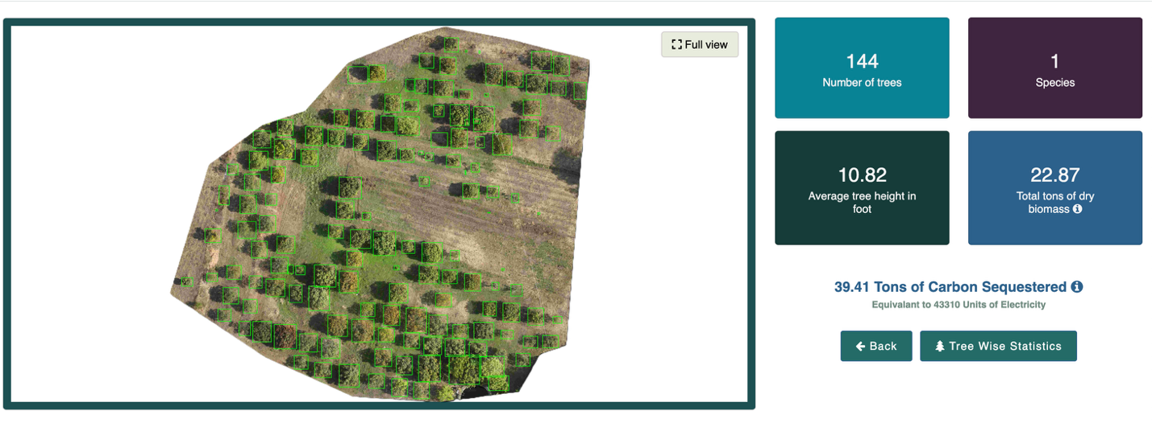

*Screenshot of tree detection interface*

* Links to videos, reports, or external media

Fast Forward Demo Day: <https://www.youtube.com/watch?v=tylnVcOa4wg&t=20s>

How our drone tech works: <https://www.youtube.com/watch?v=JDXYHLDOKos&t=53s>

## **Tools Logo to add**

* QGIS
* Google Earth Engine
* Drone Orthomosaics
* DeepForest
* Detectron2
* Zoho CRM
* KoBo Toolbox
* Google Workspace
* React
* PHP
* MySQL

# **Case study 3 - I-Saksham (Keyword: Leadership Development)**

**Thumbnail Header:** Scaling Grassroot Leadership with Purpose Built AI

**Header - Scaling Grassroot Leadership with Purpose Built AI**

## **Quick facts**

|  |  |
| --- | --- |
| **Category** | **Details** |
| Organisation Name | I-Saksham |
| Organisation Website Link | https://www.i-saksham.org |
| Founding Year | 2015 |
| Number of Beneficiaries served | 600+ fellows trained, impacting over 12,000 children and 10,000 parents |
| Geography Served | Rural Bihar |
| SDG Alignment | SDG 4: Quality Education  SDG 5: Gender Equality  SDG 10: Reduced Inequalities |
| Focus Area | Programmatic Impact, Operational Efficiency, Capacity Building |
| Functions Impacted | Program Delivery, Peer Coaching, Internal Feedback Systems |

## **Summary**

**Impact Numbers**

1. **50% increase** in mentoring coverage
2. **17% reduction** in per-fellow mentoring cost
3. **30% boost** in buddy efficiency

**About the Organisation**

I-Saksham is a grassroots nonprofit working to empower young women from marginalized communities as edu-leaders, equipping them to deliver quality education and transform their communities through a two-year fellowship program.

**Problem Statement**

I-Saksham faced significant bottlenecks in its peer coaching "Buddy Talk" process, essential for edu-leader development. Manual, time-intensive feedback led to delays (20-30 days), low buddy-to-fellow ratios (1:8), inconsistent coaching quality, and unstructured data, hindering efficient scaling of their human-centered mentoring model.

**Solution**

I-Saksham implemented an AI-assisted mentoring solution to streamline the "Buddy Talk" process. This involved leveraging technology to automate and accelerate feedback, reducing operational burden while maintaining a human-centered approach. The solution was rolled out using a phased, user-driven strategy, engaging field teams as co-designers to ensure effective adoption.

**Key Learnings**

* **User-centric design** is crucial for tech adoption and building trust.
* **AI acts as a co-pilot**, enhancing human work, not replacing it.
* **Small, contextual innovations** can drive significant systemic change.

**Key technology Used**

* Whisper (audio transcription)
* Gemini (LLM summarization)
* Custom MIS
* Google Workspace
* Azure
* AWS
* Zoom
* WhatsApp Chatbot

## **Full Case Study**

**Challenge**

Peer coaching at I-Saksham hit a bottleneck due to unstructured support for buddies and a time-heavy feedback process that delayed insights and strained capacity.

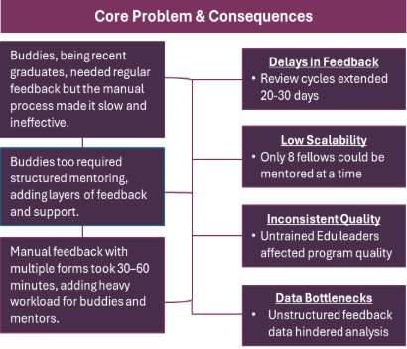

Every edu leader is assigned a coach known as a buddy and the peer coaching conversations are key to the development of the edu leader. Building capacity of buddies to conduct effective coaching is also critical as they are recent graduates from the fellowship.

As the fellowship scaled, I-Saksham faced a key bottleneck in its Buddy Talk process—the peer coaching conversations between edu-leaders and their assigned buddies. Since buddies were recent graduates, they too needed structured support, creating a dual mentoring requirement.

The manual, two-step feedback process was time intensive. Buddies submitted detailed forms after each session, which were reviewed by mentors who added their own feedback. Each cycle took 30 to 60 minutes, placing a heavy documentation burden on both roles.

This led to delayed feedback (20–30 days), low buddy-to-fellow ratios (1:8), inconsistent coaching quality, and unstructured data that was difficult to analyze. i-Saksham needed a solution that would reduce this operational load without compromising its human-centered mentoring model.

**Solution Development**

This led to a roll out of a user-led tech solution that streamlined peer coaching by enhancing human processes through co-design and iterative pilots.

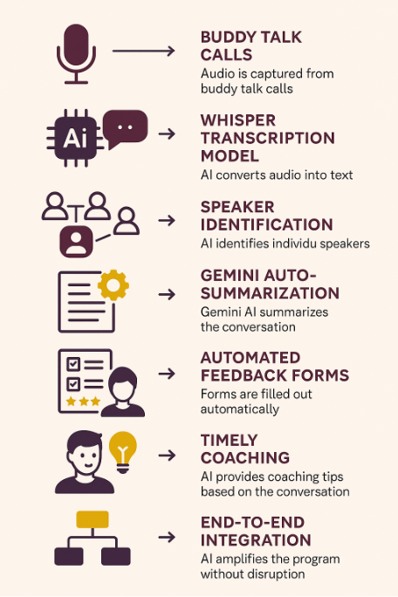

The solution rollout followed a phased, user-driven approach. Starting with pilot cohorts, the tech was tested, adapted, and integrated into existing workflows. Field teams were treated as co-designers, not end users fostering trust and ensuring adoption.

A lean, 7-member tech/data team supported implementation, and monthly review cycles maintained strategic alignment. The focus wasn’t on replacing human processes but making them faster, lighter, and more consistent.

Impact

**AI-assisted mentoring enhanced efficiency, improved feedback quality, and enabled scalable, human-centered growth**

The shift to AI-assisted mentoring produced outsized results:

* 50% increase in mentoring coverage (8 → 12–16 fellows per buddy)
* 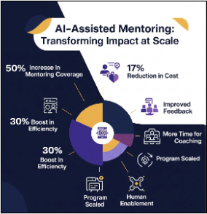
* 17% reduction in per-fellow mentoring cost
* 30% boost in buddy efficiency
* Significant improvement in feedback quality and timeliness
* Staff time freed for coaching and strategic focus
* Program scaled without compromising its core values
* Not just digital transformation but human enablement at scale.

1. Tech Stack

|  |  |
| --- | --- |
| **Tools / Vendors** | **Purpose** |
| Google Workspace | Early MIS setup |
| Gemini 1.5 | AI-based transcription & feedback summarization |
| Azure & AWS Credits | Cloud infrastructure |
| Custom MIS + WhatsApp Bot | Reporting, integration, user adoption |
| Zoom | Remote mentoring and communication |

The result: a tightly integrated system that worked with users, not against them.

1. Adaptability In the Sector

* NGOs running mentoring or fellowship programs (e.g., TFI, Piramal Foundation)
* Healthcare nonprofits supervising field workers
* CSR programs tracking trainers or volunteers
* Rural incubators offering coaching/mentoring
* Any org using call-based support or peer feedback loops

## **Tools Logo to add**

1. Whisper
2. Gemini
3. Custom MIS
4. Google Workspace
5. Azure
6. AWS
7. Zoom
8. WhatsApp Chatbot

# **Case study 4 - Vipla Foundation (Keyword: Early Childhood Edtech)**

**Thumbnail Header:** Digital Enablement for Early Childhood Education

Header: Reimagining Balwadi Program - Digital Enablement for Early Childhood Education

## **Quick Facts**

Q

|  |  |
| --- | --- |
| **Category** | **Details** |
| Organisation Name | Vipla Foundation |
| Organisation Website Link | https://www.viplafoundation.org |
| About the organization | Vipla Foundation (formerly Save The Children India) is committed to enabling access to education, healthcare, and protection for children from vulnerable communities, with a focus on holistic early childhood development. |
| Founding Year | 1988 |
| Number of Beneficiaries served | Vipla has impacted over a 1,00,000 young preschool children and trained 800 teachers. |
| Geography Served | Primarily Maharashtra (especially Mumbai and Thane); expanding through partnerships |
| SDG Alignment | SDG 3: Good Health and Well-Being  SDG 4: Quality Education  SDG 10: Reduced Inequalities |
| Focus Area | Programmatic Impact and Operational Efficiency |
| Functions Impacted | Program Delivery / Beneficiary Services; additionally impacted Teacher Training & Monitoring |
| DT Case Study - Key Technologies Used | Mobile App (“Umang”), Data Dashboards, MIS-based Reporting Interface |

## **Summary**

**Impact Numbers**

**91%** Teachers used app regularly

**31% increase** in Student attendance

**10% increase** in Continuous Learning Evaluation scores

**About the Organisation**

Vipla Foundation, formerly Save The Children India, has worked for over three decades to support inclusive development, especially in underserved communities. Central to its early childhood education initiatives is the Balwadi Program, which operates over 50 community-run Balwadis and supports 800 government preschools across Mumbai and Delhi. These centers are designed to build community-led capacity and improve learning outcomes for preschool children through structured teaching, regular mentorship, and data-driven monitoring.

**Problem Statement**

Vipla Foundation faced significant operational hurdles in scaling and ensuring quality across its extensive Balwadi network. This included challenges in efficient data collection, monitoring teacher performance, tracking student progress, and delivering consistent educational quality, leading to administrative burdens and hindering timely, data-backed instructional support.

**Solution**

Vipla Foundation co-developed "UMANG," a comprehensive mobile application suite for Balwadi teachers and mentors. This user-centric solution aimed to minimize administrative tasks, ensure data accuracy, and facilitate timely, data-driven instructional support, allowing for real-time tracking of student progress and teacher performance.

**Key Learnings**

* Simple, local-language design is vital for frontline user adoption.
* Real-time data empowers both teaching and mentoring effectiveness.
* Strong change management with training ensures sustained tech use.

**Key technology Used**

Mobile App (“Umang”), Data Dashboards, MIS-based Reporting Interface

## **Full Case Study**

1. Challenges

**Vipla Foundation struggled in scaling quality across Balwadis despite strong community roots and mentor expertise.**

Despite its deep community presence and experienced mentor network, Vipla Foundation faced significant operational hurdles in scaling and sustaining quality across its Balwadi network:

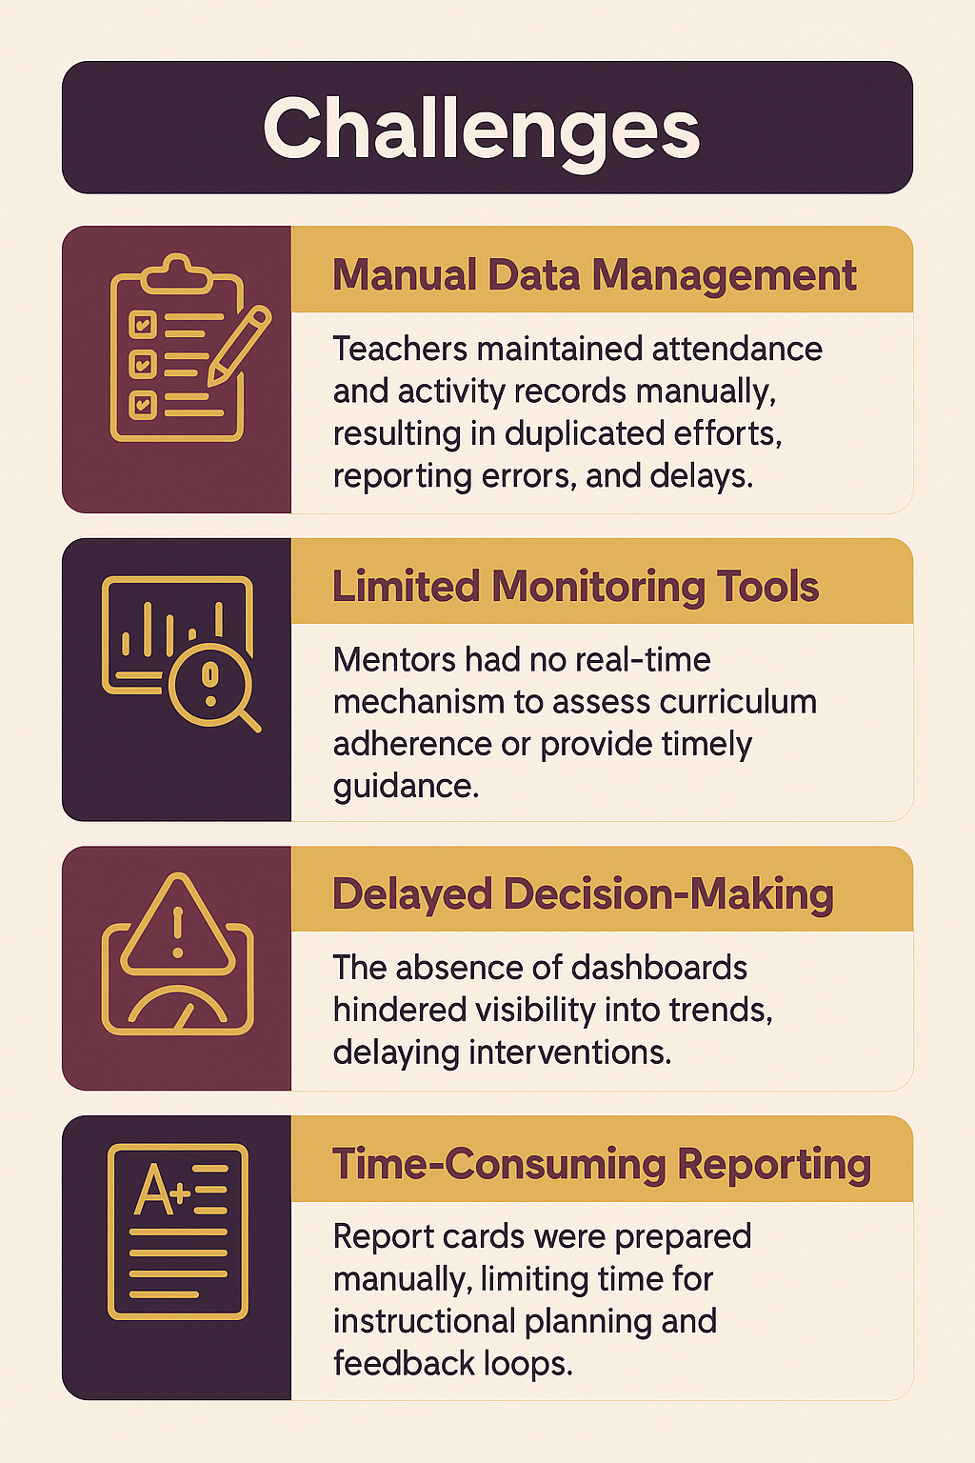

1. Solution

Led to the development of UMANG, a digital app suited for teachers and mentors that streamlined data and support, enabling scalable, government-backed impact.

To address these issues, Vipla Foundation co-developed a robust digital solution “UMANG”, a mobile application suite tailored for both Balwadi teachers and mentors. Designed through a user-centered lens, the apps reduce administrative burden, ensure data integrity, and foster timely, data-backed instructional support.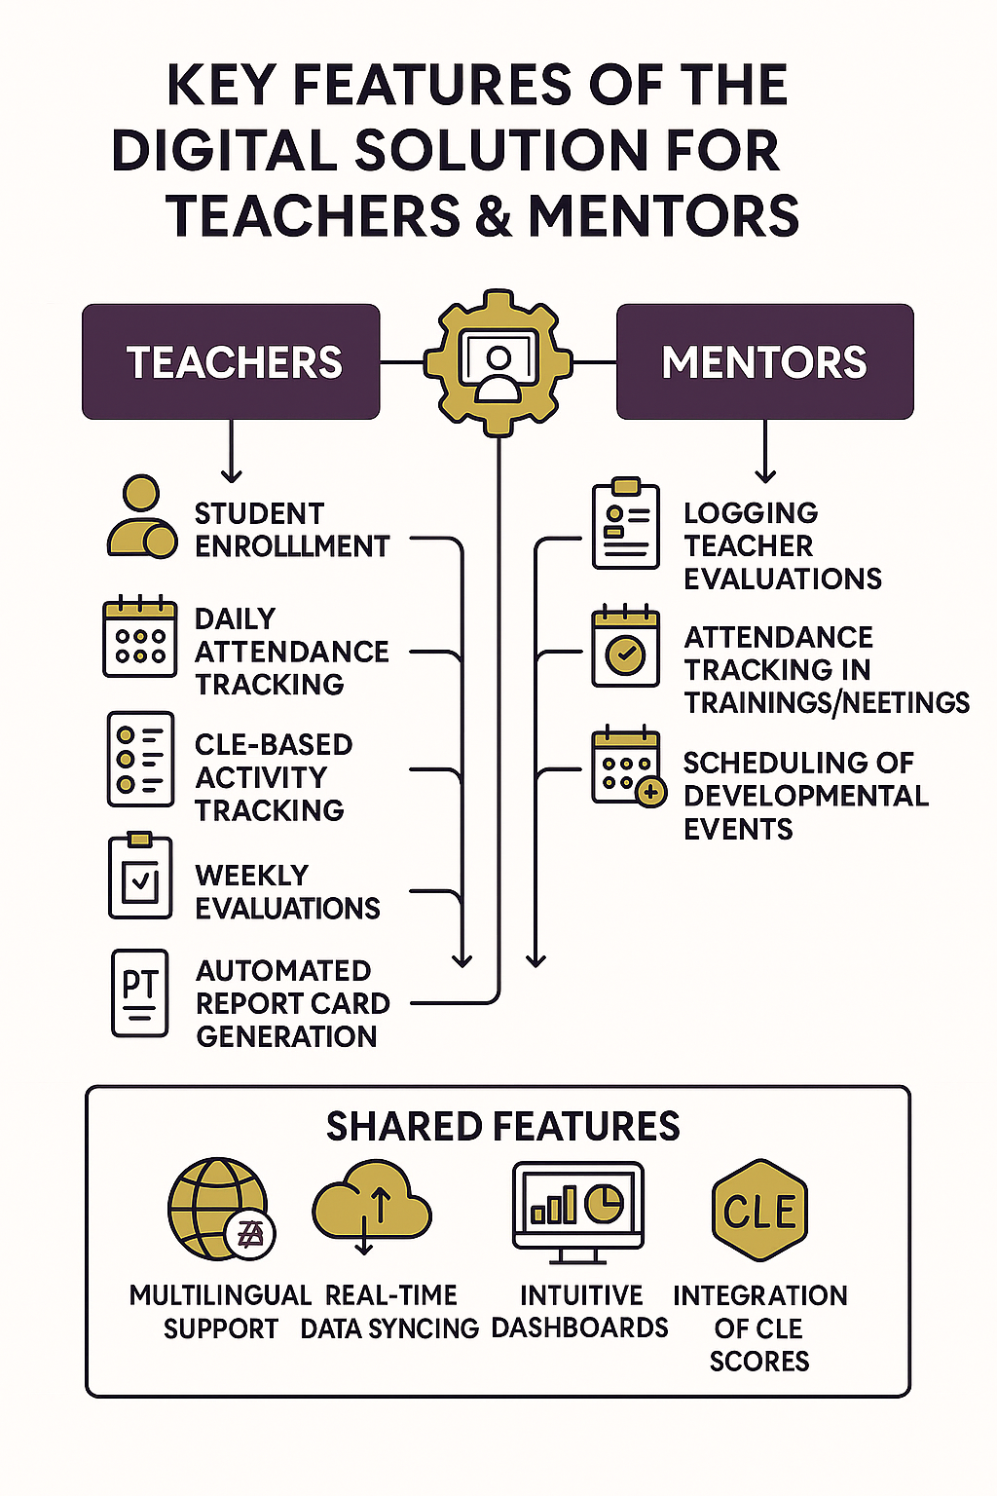

* **Teacher App**: Enables real-time data entry for student enrollment, attendance, daily learning activities, weekly CLEs (Child Learning Evaluations), and medical evaluations. Teachers can generate report cards and share them digitally or physically with parents.
* **Mentor App:** Allows mentors to track teacher attendance, classroom observations, training participation, and evaluation outcomes. It also enables scheduling and event management.

1. Solution Roll-Out Approach

Vipla Foundation adopted a phased, participatory approach for implementation:

1. Design Thinking & Co-Creation: Teachers and mentors were engaged in app prototyping to ensure usability aligned with on-ground realities.
2. Pilot Testing: The platform was piloted in select Balwadis for iterative feedback and debugging.
3. Training & Capacity Building: Over 800 teachers and mentors underwent hands-on training and support, reinforcing comfort with digital tools.
4. Data Governance Protocols: Standardized reporting formats and real-time dashboards were developed to ensure smooth reporting and accountability.
5. Scale-Up with Government Partnership: Strong results enabled a 21x scale-up from 50 to 1100 Balwadis, with government adoption playing a key role.

**Impact**

**Boosted student learning, teacher performance, and classroom engagement across the Balwadi network.**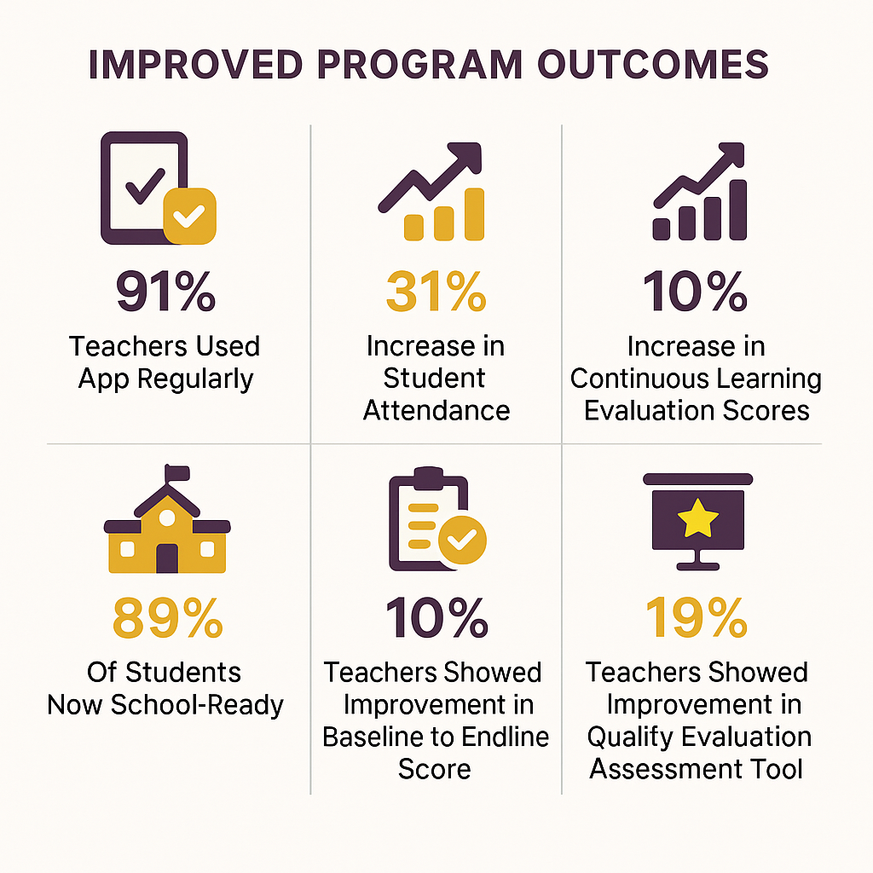

* 91% Teachers used app regularly
* 31% increase in Student attendance
* 10% increase in Continuous Learning Evaluation scores
* 89% of students now school-ready
* 10% teachers showed improvement in Baseline to Endline score
* 19% teachers showed improvement in Quality Evaluation Assessment Tool

1. Tech Stack

| **Component** | **Details** |
| --- | --- |
| Mobile Platform | Android-based mobile apps |
| Backend | Secure cloud-based server for data syncing |
| Languages | Multilingual interface to support diverse user base |
| Features | -Offline data entry with sync capability- Real-time dashboards- PDF report generation- Activity logs |

1. Adaptability In the Sector

Vipla Foundation’s success with the Umang platform underscores its potential beyond early childhood education. Key attributes of the solution—customizability, multilingual support, offline functionality, and intuitive interface—make it suitable for:

1. **Healthcare Programs**: Tracking health worker visits, child health metrics, and community outreach.
2. **Skill Development**: Monitoring vocational training attendance, skill assessments, and placement records.
3. **Women Empowerment Initiatives**: Documenting SHG (Self Help Group) activities, savings, training participation, and impact metrics.

## **Tools logo to add**

Umang (Mobile App)

# **Case Study 5 - Akshay Patra (Keyword:Supply Chain Optimization)**

**Thumbnail Header:** Optimizing Operations to Feed Millions

## **Quick Facts**

|  |  |
| --- | --- |
| **Category** | **Details** |
| Organisation Name | The Akshaya Patra Foundation |
| Organisation Website Link | <https://www.akshayapatra.org> |
| Founding Year | 2000 |
| Number of Beneficiaries served | 2.35 million children daily, cumulatively – over 4 Billion meals served. |
| Geography Served | 16 States across India |
| Focus Area | Operational Efficiency |
| Functions Impacted | **Program Delivery:** Order Management, Distribution, Meal Delivery & Quality  **Internal Functions:** Fleet, Logistics, Procurement, Production, Inventory, Contracts, Invoicing |
| SDG Alignment | SDG 2 (Zero Hunger), SDG 4 (Quality Education), SDG 9 (Industry, Innovation & Infrastructure) |

## **Summary**

**Impact numbers**

* 2.35M Meals Daily
* 4 Billion+ Meals Served
* 19 Geographies Optimized, Cost

**About The Akshaya Patra Foundation**

A not-for-profit organization headquartered in Bengaluru, India. It strives to eliminate classroom hunger by implementing the Mid-Day Meal Scheme in government schools and government-aided schools, aiming to counter malnutrition and support the right to education of children.

**The Challenge**

Akshaya Patra's ambitious 2M+ daily meal service faced systemic challenges from fragmented, manual supply chain operations, hindering real-time visibility into logistics and production, inaccurate data, and inefficiencies in fleet, inventory, and contract management, directly impacting meal quality, cost-efficiency, and mission scalability.

**The Solution**

Akshaya Patra undertook a comprehensive digital transformation via "Project Disha" (Distribution Excellence) and "Project Poorna" (Production Efficiency). This involved implementing Microsoft Dynamics ERP as its backbone, leveraging Azure for scalable infrastructure, and deploying tailored mobile applications (PowerApps, OS1) and specialized systems (Kelsa, Zing HR) to digitize end-to-end supply chain operations, from order management to last-mile delivery and kitchen production.

**Key Learnings**

* Phased integration ensures seamless data flow across complex supply chains.
* Real-time mobile data empowers frontline staff and enables proactive management.
* Centralized visibility drives agile, data-backed decision-making for operations.

**Core Technologies**

* Microsoft Dynamics ERP (AX2009, D365)
* Microsoft Azure IaaS & CDN
* Salesforce CRM
* PowerApps, OS1 (Mobile App Development)
* IIOT enablement
* Kelsa (Logistics)
* Zing HR (HRMS)
* Mana Data Dashboards

## **Full Case Study**

**Challenge**

**Scaling operations while upholding quality and efficiency proved a systemic challenge for Akshaya Patra, constrained by pervasive manual processes across its extensive supply chain.**

Akshaya Patra, with its ambitious mission of serving over 2 million meals daily across multiple states, faced monumental supply chain complexities amplified by rapid growth and inflationary pressures. The issues were systemic and multi-faceted, significantly hindering their ability to deliver meals effectively and cost-efficiently.

Primarily, the lack of digitization across critical distribution and production functions led to significant dependency on manual processes:

* **Order Management Inefficiencies:** Manual order uploads, vessel tracking (filled/empty), and route management resulted in:
  + Sub-optimal route planning and poor real-time visibility.
  + Inaccurate time-stamp capturing, complicating deviation analysis.
  + Challenges in real-time delivery acknowledgment (taste, adequacy, on-time).
  + Inefficient vessel return tracking.
* **Sub-optimal Fleet Management:** Absence of a robust digital system meant:
  + Limited mileage and fuel consumption analysis.
  + Inefficient tracking of repair/maintenance spend, preventing true cost-per-kilometer analysis.
  + Sub-optimal management of fleet expenditure and fuel balancing.
* **Compliance & Document Headaches:** Manual methods for contracts, invoicing, and document management created:
  + Tedious upload and tracking of essential documents (insurance, registration, licenses, health records).
  + Lack of automated renewal prompts, increasing non-compliance risk.
  + Inefficient management of hired vehicle contracts and invoice verification.
* **Production Inconsistencies (Project Poorna):** Manual data entries and calculations on the production floor led to:
  + Inaccuracies in material input times and cycle times.
  + Deviations from set recipes, affecting meal quality and consistency.
  + Limited real-time visibility into production metrics during operations, hampering timely decision-making.

These systemic inefficiencies directly impacted the timely production and cost-effectiveness of meals, posing a significant threat to their core mission's scalability and beneficiary satisfaction.

**Solution**

**Akshaya Patra revolutionized its supply chain through "Project Disha" and "Project Poorna," deploying a comprehensive, multi-platform digital ecosystem to optimize production and last-mile delivery.**

Akshaya Patra's digital transformation journey epitomizes strategic prioritization and phased implementation, driven by a clear understanding of its operational bottlenecks.

**Phase 1: Strategic Prioritization & Foundational Digitization**

* **Core Focus:** Prioritized digitizing foundational elements: Indenting and Information, followed by Order Management and Fleet Management. This streamlined the flow of information and meals from kitchen to school, addressing the primary objective of efficient daily meal delivery.
* **Simultaneous Production Optimization:** Concurrently, "Project Poorna" focused on optimizing kitchen production, recognizing its paramount role in scale and cost reduction.

**Phase 2: Multi-Platform Technology Adoption & Integration**

* **ERP Backbone:** **Microsoft Dynamics ERP (AX2009, D365)** became the core backbone, handling financial management and expanding to broader operational aspects, critical for managing complex operations and yield factors.
* **Cloud Infrastructure:** Migration to **Microsoft Azure IaaS & CDN** established a reliable, scalable, real-time data infrastructure, improving content delivery and accessibility across dispersed operations.
* **Stakeholder Engagement:** **Salesforce CRM** (introduced 2020) manages donor relations and partnerships, providing real-time visibility into available resources for operations.
* **Custom Mobile Solutions:** **PowerApps & OS1** enabled development of tailored mobile applications for "Project Disha" (Order Management) and "Project Poorna" (Production Efficiency), providing app-guided material input and real-time tracking.
* **Advanced Data Capture:** **IIOT enablement** is being integrated for "Project Poorna" to enhance production floor data capture and process visibility.
* **Specialized Systems:** **Kelsa** serves as a specialized logistics/fleet management system, while **Zing HR** automates the entire HR lifecycle, supporting the large workforce.
* **Technology Rationale:** Choices driven by scalability, integration capabilities, cost, speed of deployment, and ability to provide real-time data and mobile accessibility.

**Phase 3: Hybrid Implementation & Continuous Evolution**

* **Team & Approach:** A strong internal Operational Excellence and Technology Team led the drive, collaborating with external implementation partners and consultants for specialized expertise. This hybrid approach ensured deep customization and seamless integration.
* **Implementation Strategy:** Systematic project initiatives (Disha, Poorna) marked implementation. Key to adoption was developing user-friendly mobile applications for source-level data digitization, supported by extensive training and clear communication across thousands of users.
* **Phased Evolution & Milestones:** Akshaya Patra's journey is continuous:
  + **2011-2018:** Initial ERP deployment and full Dynamics ERP integration.
  + **2014-2016:** Cloud foundation built with Azure IaaS and Microsoft 365, strengthening infrastructure.
  + **2020:** Salesforce CRM implemented.
  + **2022-2024:** Further D365 expansion, Azure CDN addition, "Project Disha" (Fleet Management), HRMS Digitization (Zing HR), "Project Poorna" (Production Efficiency), and Customer Survey initiatives.
* **Critical Decisions:** Early commitment to a comprehensive ERP (Dynamics) for a centralized backbone, the strategic move to Azure for scalability, and recent investment in purpose-built mobile applications for on-ground empowerment were crucial turning points.

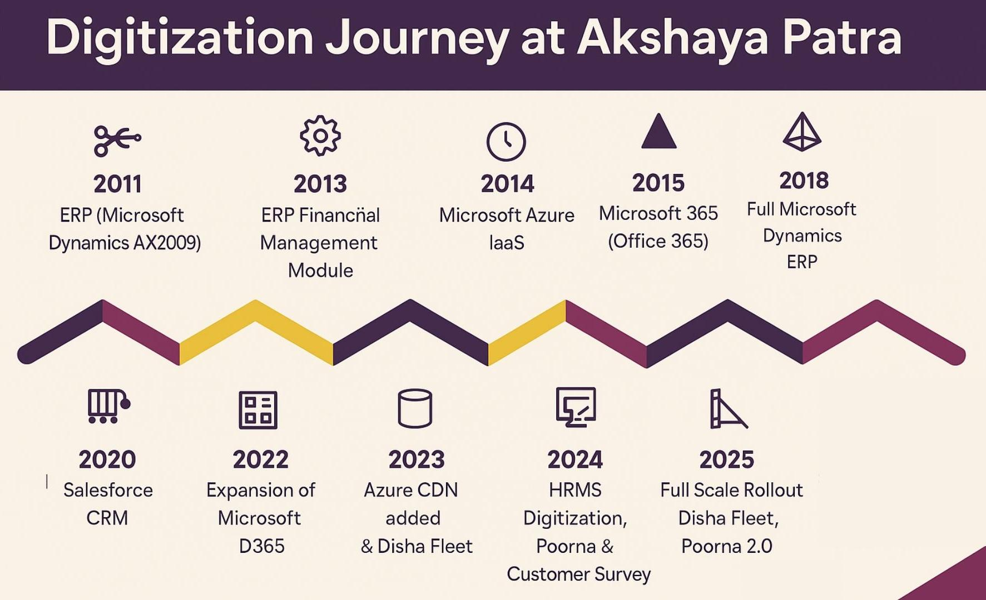

**Funding:** Digital transformation was largely supported by deep discounts and pro-bono contributions from partners like Fidelity, Delhivery, and Microsoft, recognizing the long-term impact of digital efficiency and transparency in a PPP and not-for-profit model.

**Outcome & Impact**

**Akshaya Patra now delivers over 2.35 million meals daily with unprecedented efficiency, transparency, and quality, driven by real-time data and optimized supply chain operations.**

Akshaya Patra's digital transformation has profoundly redefined its operational capabilities and significantly amplified its mission impact, delivering tangible benefits across its entire ecosystem.

**1. Optimized Meal Delivery & Enhanced Beneficiary Experience:**

* **Primary Beneficiaries:** **2.35 million children daily** receive more consistent, timely, and higher-quality meals.
* **Streamlined Logistics:** Drivers and logistics teams benefit from **real-time mileage analysis, fuel consumption insights, and automated repair tracking**, enabling precise "Cost Per Kilometer" analysis and significant cost reductions.
* **Improved Order Management:** Digitized processes for order uploads, tracking, and acknowledgments ensure **end-to-end visibility** and accountability.

**2. Production Efficiency & Quality Assurance:**

* **Reduced Cycle Times:** "Project Poorna" introduced app-guided material input, leading to **reduced meal preparation times** and minimized waste.
* **Consistent Quality:** Digital processes and IIOT enablement ensure **adherence to recipes**, directly improving meal consistency and quality.
* **Resource Optimization:** Enhanced traceability from production to delivery and better utilization of vessels, vehicles, and manpower.

**3. Data-Driven Management & Strengthened Credibility:**

* **Real-Time Visibility:** Mana dashboards provide a single source of truth, enabling **proactive management and immediate deviation analysis**, shifting from reactive problem-solving.
* **Empowered Teams:** The "Discipline, Digitalization, Data-backed decisions" culture fosters accountability and continuous improvement across kitchen, field, and management teams.
* **Enhanced Compliance:** Digitization of contracts and automated renewal prompts streamline compliance and significantly reduce administrative burden and risk.
* **Increased Stakeholder Trust:** Demonstrating robust systems for financial accountability and operational excellence reinforces Akshaya Patra’s commitment to transparency, attracting more support and fostering stronger partnerships (SDG 9 alignment).

## **Tools Logo to add**

1. **Microsoft Dynamics ERP (AX2009, D365)**
2. **Microsoft Azure (IaaS & CDN)**
3. **Salesforce CRM**
4. **PowerApps**
5. **OS1** (Mobile App Development)
6. **Kelsa** (Logistics)
7. **Zing HR** (HRMS)
8. **Mana Data Dashboards**

# **Case Study 6 - Anudip (Keyword:Digital Skilling & Employability)**

**Thumbnail Header:** Skilling with Smart Systems

**Header: Scaling Inclusive Digital Livelihoods Through Technology & AI**

## **Quick Facts**

|  |  |
| --- | --- |
| **Category** | **Details** |
| **Organisation Name** | Anudip Foundation for Social Welfare |
| **Organisation Website Link** | https://anudip.org/ |
| **Founding Year** | 2007 |
| **Number of Beneficiaries served** | *500,000+ youth* |
| **Geography Served** | *22 States across India* |
| **SDG Alignment** | SDG 4 (Quality Education), SDG 5 (Gender Equality), SDG 8 (Decent Work) |
| **Focus Area** | *Programmatic Impact, Operational Efficiency* |
| **DT Case Study - Functions Impacted** | *Program Delivery, Beneficiary Services, Data & Analytics, Placements* |

## **Summary**

**Impact numbers**

* 70%+ Placement Rate
* 20x Faster Job Matching
* 90+ Centers Digitized

**About The Anudip**

Anudip creates digital livelihoods for underserved communities through technology and by combining 21st century skills with Artificial Intelligence (AI) applications. Since their inception in 2007, Anudip has impacted 500,000+ lives by providing technology-driven employability and entrepreneurship for crisis-stricken youth and women

**Problem Statement**

Anudip's rapid growth exposed the limitations of its manual, fragmented legacy model, hindering seamless learner journeys, consistent quality, data-driven decision-making, and equitable scale across diverse geographies**.**

**The Solution**

Anudip undertook a deliberate digital transformation, building a hybrid technology ecosystem (CMIS, LMS, custom tools like JD-CV Match, AI applications) to streamline the learner journey, standardize content, enable personalized support, and make data actionable, all while amplifying human capacity.

**Key Learnings**

* Technology must be mission-anchored, not trend-driven.
* Co-ownership by people drives adoption.
* Data must drive action, not just documentation.

**Key Technologies Used**

* *LMS*
* *Virtual Interviewers*
* *JD-CV Match*
* *Gamified Learning*
* *Micro-content Platforms*
* *Data Dashboards*

## **Full Case Study**

**The Challenge**

**Rapid growth strained a manual, fragmented model, hindering seamless learner journeys, consistent quality, and scalable impact.**

As the organization expanded exponentially over nearly two decades, the scale and diversity of its operations began to strain a legacy model heavily reliant on manual effort, fragmented processes, and localized expertise. This created significant barriers to delivering consistent quality and impact.

* **Fragmented Learner Journey:** The entire learner journey—from mobilization and enrollment to training, mentoring, and placement—lacked seamless orchestration. Systems did not communicate, data was trapped in silos, and frontline teams struggled to maintain quality across diverse learner profiles (varying digital readiness, linguistic backgrounds, exposure) and geographies.
* **Inconsistent Quality & Support:** Trainer variability, especially in delivering soft skills and English communication, affected consistency. Delivering personalized support was challenging in large batches, while mentorship systems were informal, and alumni engagement lacked structure or scale.
* **Limited Data Utility:** Despite accumulating a wealth of data, the organization lacked the tools to draw timely insights or effectively use data for decision-making and impact reporting.
* **Constraints to Equitable Scale:** These gaps severely constrained its ability to scale equitably, respond dynamically to learner needs, and credibly demonstrate outcomes to funders and partners. The imperative was not merely digitization, but a complete reimagination of its delivery engine.
* **Human-Centric Solution Required:** The challenge was to build a cohesive, end-to-end technology ecosystem that could amplify—rather than replace—human capacity, ensure quality at scale, and remain grounded in inclusivity and affordability.

3. Solution

**A deliberate digital transformation built a hybrid tech ecosystem to streamline learner journeys, standardize content, enable personalized support, and leverage data, amplifying human capacity.**

Its digital transformation journey was a deliberate, thoughtful shift to reimagine how it delivers impact, rooted in the needs of its learners, teams, and partners. Rather than seeing technology as a silver bullet, it was embraced as an enabler to solve specific problems, reduce repetition, and free up human teams for mentoring and guidance.

**Key Phases and Initiatives:**

* **Strategic Prioritization & Bottleneck Identification:** The journey began by identifying critical bottlenecks across the entire learner journey—from enrollment to placement and alumni outreach. Solutions were prioritized where technology could specifically address these issues and enhance human intervention.
* **Hybrid Technology Ecosystem Implementation:** A strategic mix of internally-built tools and carefully selected external platforms was adopted.
  + **Core Systems:** Implemented a Computer Management Information System (CMIS) to streamline enrollment, batch creation, and documentation. A Learning Management System (LMS) was integrated to standardize content delivery and track learner progress.
  + **Custom High-Impact Tools:** Developed bespoke tools like the "JD-CV Match" engine to help placement teams efficiently connect students with suitable jobs. A "Virtual Interview Module" was created to provide structured, low-pressure practice environments, enhancing student readiness without constant trainer intervention.
  + **AI Integration:** Leveraged AI in tools like the "iChat AI coach" and other applications for content generation and support, focusing on solving urgent, recurring operational gaps.
* **Strategic Build vs. Buy Approach:** Where in-house expertise was strong (e.g., digital learning content, system design), internal development was prioritized. For enterprise-level system integration or specialized skills, external vendors were engaged through structured processes, often supported by pro bono partnerships and donor-backed initiatives, ensuring agility and cost-efficiency.
* **Robust Change Management & Adoption:** Critical to implementation was deep involvement from trainers, center heads, and state teams from day one. Weekly training workshops, system walkthroughs, open forums, data helpdesks, and regional champions ensured concerns were addressed, feedback loops were active, and adoption was organic and sustainable.
* **Phased Transformation Rollout:** The transformation unfolded in strategic phases:
  + **Phase 1:** Focused on core digitization of enrollment and training processes.
  + **Phase 2:** Brought in integration between various systems, introduced data dashboards, and developed tools for mentorship.
  + **Phase 3 (In Progress):** Concentrates on deepening personalization, improving mobile-first access, and enhancing alumni engagement.
* **Sustainable Funding Model:** Funding was secured through a mix of donor grants and in-kind contributions. Partners' belief in the mission provided confidence to innovate and scale.
* **Human-Centered Design Philosophy:** At its heart, the transformation aimed to enhance human capacity—not replace it—by building a system that respects the complexity of the learner journey, values field teams’ experience, and multiplies collective impact through technology.

4. Outcomes & Impact

**This digital transformation enhanced program quality and efficiency, accelerating scalable service to underserved communities.**

The digital transformation profoundly improved its operational capabilities and amplified its mission impact, delivering tangible benefits across its ecosystem of learners, teams, and partners.

**1. Enhanced Learner Experience & Outcomes:**

* **Consistent Quality:** Standardized content delivery through the LMS reduced trainer variability, ensuring equitable access to quality lessons regardless of location.
* **Improved Job Readiness:** Tools like JD-CV Match, digital assessments, and virtual interview prep helped students prepare for jobs more effectively, even in remote or under-resourced centers.
* **Sustained Support:** Mentorship tools and alumni engagement platforms strengthened long-term support beyond the classroom.
* **Measurable Outcomes:** Achieved a **70%+ placement rate** across eligible learners maintained year over year. Candidate-job mapping became **20x faster** using the JD-CV Match tool. Learner feedback participation **tripled**, with improved learner satisfaction scores.

**2. Optimized Operational Efficiency & Scale:**

* **Streamlined Workflows:** Digitized workflows significantly improved operational efficiency; for instance, enrollment processes that once took days could now be completed in hours.
* **Content Creation:** Content creation became **8x faster** through modular digital content tools.
* **Centralized Oversight:** **90+ centers** were fully digitized, enabling centralized oversight and support.
* **Real-time Management:** Trainers and center managers gained real-time dashboards to track attendance and engagement. Placement teams could match candidates to jobs faster, supported by structured data.

**3. Data-Driven Decision-Making & Team Empowerment:**

* **Data-Informed Decisions:** Internally, the transformation fostered increased cross-functional collaboration, with tech and program teams co-owning processes. Decision-making became significantly more data-informed, with dashboards and weekly review meetings enabling prompt identification of drop-offs and continuous adaptation.
* **Proactive Operations:** The organization transitioned from being reactive to proactive in delivering its mission.
* **Empowered Teams:** Trainers felt more equipped and empowered, and a renewed sense of confidence permeated across learners and staff.

**4. Strengthened Credibility & Partnerships:**

* **Enhanced Transparency:** For funders and partners, the shift was tangible, providing access to cleaner, more credible data and clearer insights into how their support translated into measurable impact.
* **Increased Support:** Several funders began supporting multi-year tech infrastructure costs, recognizing it as core to program delivery and affirming that digital is not an overhead but an enabler of long-term, systemic impact.
* **Cultural Shift:** The transformation fostered a stronger sense of confidence among learners and trainers, making students feel more seen and supported.

**6. Additional Details (Optional)**

* Screenshots of tools, dashboards, or mobile apps
* Links to videos, reports, or external media
* Any awards or recognition related to your DT journey

**Snapshots**

**Screenshots of Key Tools & Dashboards:**

1. **LMS (Learning Management System)**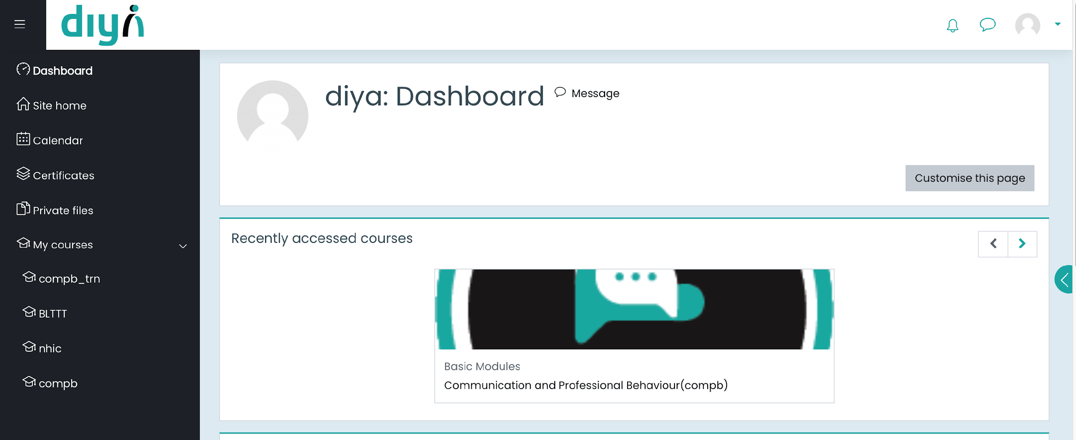

*Central platform for delivering, tracking, and managing Anudip’s digital training content and student progress*

**2. CMIS (Computerized Management Information System)** *End-to-end student lifecycle tracking—from enrollment to placement—with real-time data and analytics*

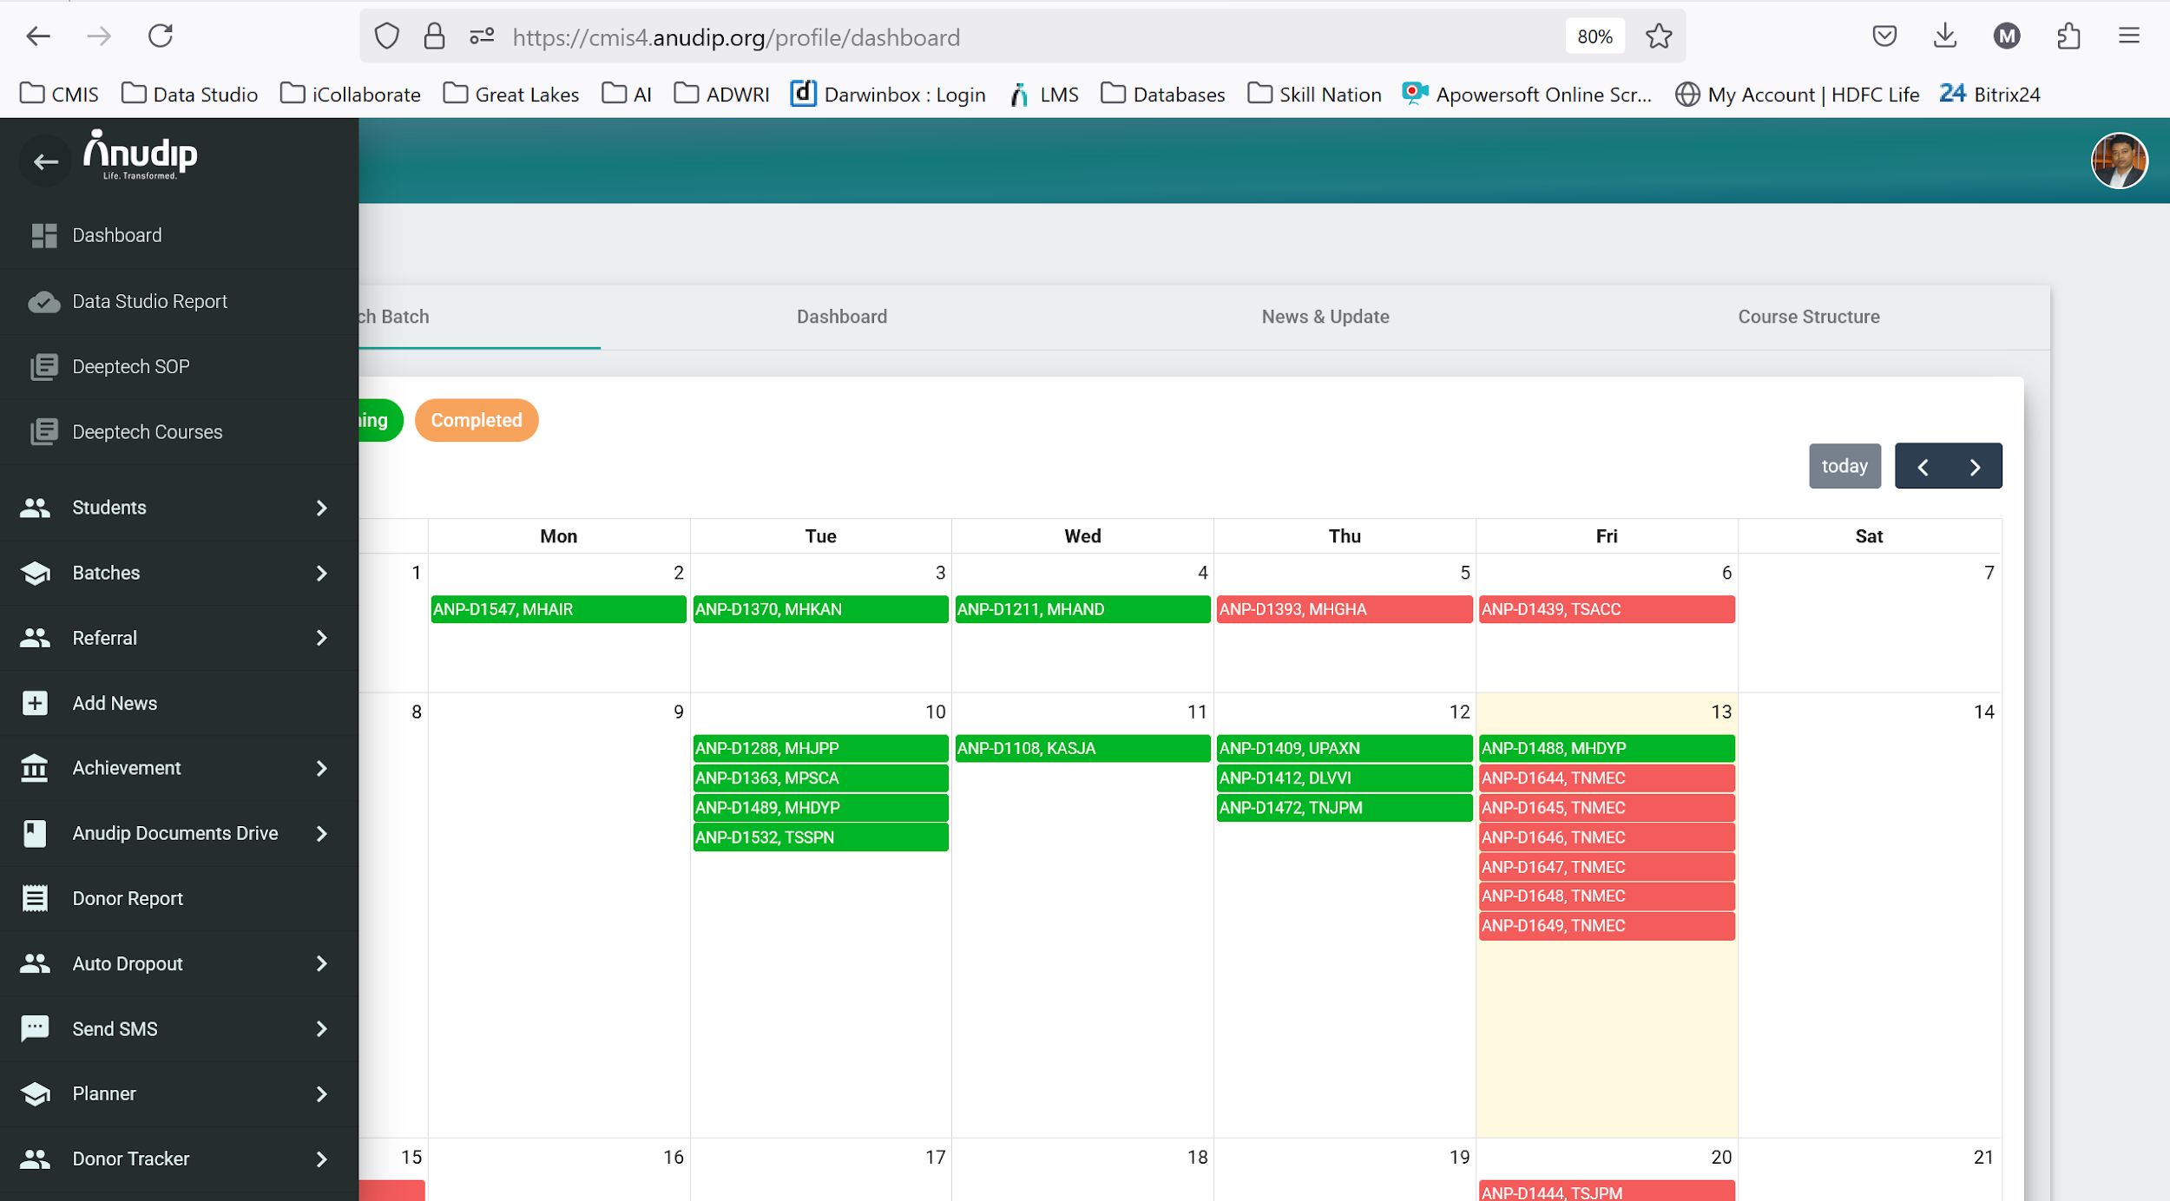

**3. iChat Quiz App**

*AI-powered quiz tool that evaluates open-ended answers, provides feedback, and suggests scores using GPT models*

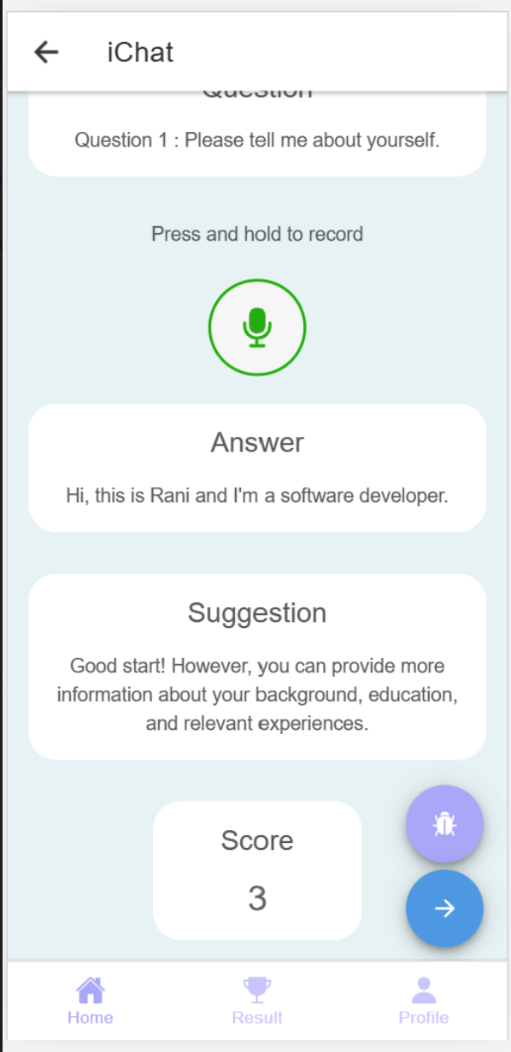

**4. Mentoring App**

*Digital platform connecting students with mentors for skill-building, guidance, and job readiness support.*

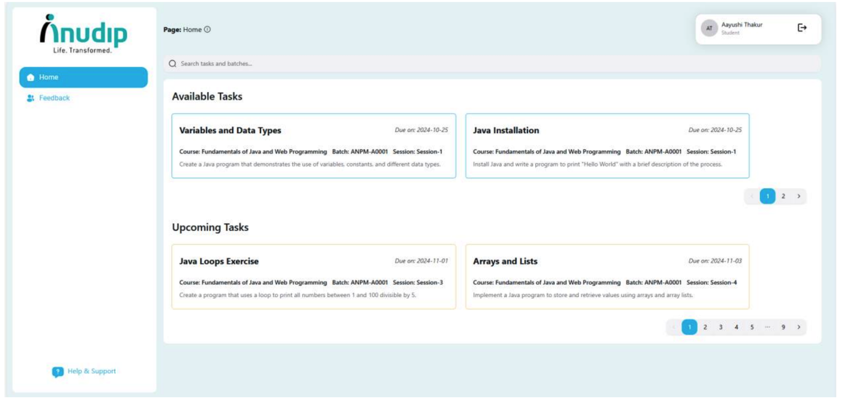

**5. Asset Management Software**

*Tool to track and manage Anudip’s physical and digital assets across locations in real time.*

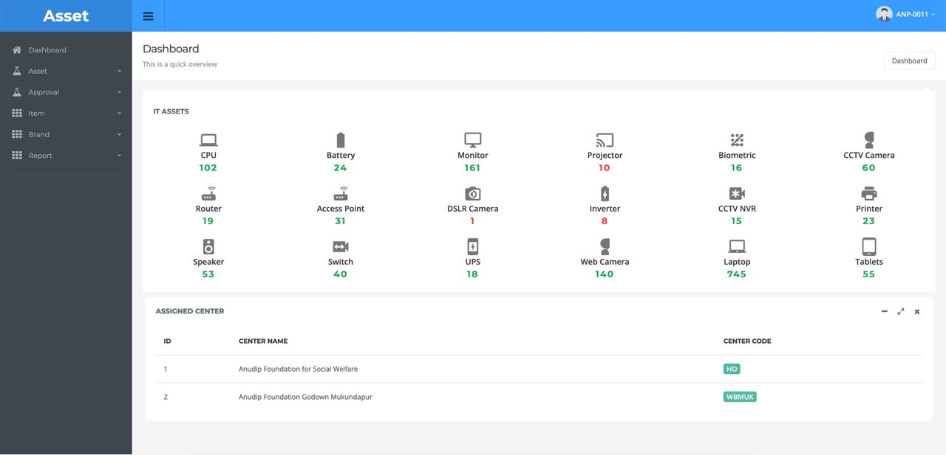

**Links to Videos & External Media:**

* [**Anudip Foundation Shines in The Telegraph: Empowering Lives Through Digital Transformation**](https://anudip.org/anudip-foundation-shines-in-the-telegraph/)
* [**"Reskilling for Tomorrow: AI & Workforce 2.0" (Jan 2025)**](https://www.business-standard.com/content/press-releases-ani/driving-social-impact-anudip-transforms-lives-through-ai-and-workforce-2-0-skilling-125012800005_1.html?utm_source=chatgpt.com)
* [**Nonprofit Evolution 2025 blog**](https://anudip.org/nonprofit-evolution-2025-where-technology-meets-compassion/?utm_source=chatgpt.com) – discusses AI-driven tools like document verification, educational nudges, and adaptive quizzes.
* [**Harnessing Digital Public Goods**](https://anudip.org/harnessing-digital-public-goods-how-anudip-foundation-is-leveraging-technology-for-social-good/?utm_source=chatgpt.com) – details Anudip’s integration of open-source platforms such as Moodle and the Diya mobile attendance app
* [**YouTube “Anudip’s Year of Empowerment”**](https://www.youtube.com/watch?v=t43D_R2lV8A) – showcases learner journeys and the impact of digital tools.

**Awards & Recognition in Digital Transformation Context:**

For a full list of recognitions, please refer to the [Awards section](https://anudip.org/awards/) on Anudip’s official website, which highlights accolades specifically related to digital transformation, skilling, and innovation.

**2025**

* ASM CSR NGO of the Year 2025
* ASM CSR Best NGO Leader of the Year 2025

**2023–2024**

* Asia‑Pacific Stevie® Awards 2023 (Silver) – Excellence in Innovation (Non-Profits)
* eNGO Challenge 2023 – Winner for Digital Solutions category
* ASSOCHAM Best Skill Development Org – Industry 4.0 (FuturePro program)
* Indian Chambers of Commerce Social Impact Award 2024 – Gender Equality & Women Empowerment
* Great Place to Work™ certified (2018, 2021–24)

**2018**

* SKOCH Order of Merit – Top digital skilling initiative

# Case Study 7 - Lend a Hand India **(Keyword:Vocational Education Digitization)**

**Thumbnail Header:** Scaling Vocational Education

**Headers:** **Scaling Vocational Education: Lend a Hand's Digital Transformation**

## Quick Facts

|  |  |
| --- | --- |
| **Category** | **Details** |
| Organisation Name | Lend a Hand India |
| Organisation Website Link | https://lendahandindia.org/ |
| Founding Year | 2006 |
| Number of Beneficiaries served | Schools : 8000+  Trainers: 11,000+  Students: 6 lakhs+ |
| Geography Served | All-India |
| Focus Area | Programmatic Impact |
| Functions Impacted | rProgram Delivery / Beneficiary Services |
| SDG Alignment | SDG 4 (Quality Education) |

## **Summary**

**Impact numbers**

* **25+ State Reach**
* **99%+ Faster Deployments**
* **Days-to-Minutes Analytics**

**About Lend A Hand India (LAHI)**

A not-for-profit organization headquartered in Pune, India works at the intersection of education and livelihood to provide youth employment and entrepreneurial opportunities. Lend A Hand India focuses on integrating vocational education with mainstream education at secondary and higher secondary education levels (Grades 9-12 and students aged 14-18) to make secondary education more meaningful and interesting for their sustainable livelihoods.

**Problem Statement**

LAHI faced systemic challenges scaling vocational education across 25+ states due to fragmented manual monitoring, outdated technology, and lack of real-time data visibility.

**Solution**

LAHI modernized program delivery by deploying Lighthouse, a custom, multi-tenant software, enabling real-time monitoring, centralized data, and AI-powered analytics, drastically improving efficiency and scalability.

**Learnings**

* Custom solutions enable scalable, flexible control.
* Centralized data integration enhances consistency and analysis speed.
* Digital transformation requires holistic approach: tech, process, people.

**Key Technologies Used**

* Lighthouse (custom software, multi-tenant)
* AWS RDS
* Power BI
* AI-based NL2SQL chatbot

## **Full Case Study**

**The Challenge**

**Hurdles in scaling and ensuring quality across its vocational education programs due to fragmented monitoring, outdated technology, and limited real-time data access.**

The complexities of delivering and monitoring vocational education across 25+ states and Union Territories posed a systemic challenge for the organization. Growing demands highlighted critical inefficiencies, hindering its ability to ensure program quality and demonstrate impact.

* **Unscalable Program Monitoring:** Difficulty in real-time tracking of trainer presence, class regularity, lab functionality, and equipment availability. Early manual data collection was inefficient and couldn't scale.
* **Technology & Infrastructure Limitations:** Reliance on rigid commercial off-the-shelf software and separate custom software (Lighthouse) instances per state led to:
  + Limited customization and increasing costs.
  + Redundant deployments and slow onboarding (1 week/instance).
  + High maintenance overhead.
* **Fragmented Data & Integration Issues:** States not using Lighthouse relied on disparate tools like Google Sheets and Kobo Forms, resulting in inconsistent data and hampering cross-state analysis.
* **Reporting & Analytics Bottlenecks:** Power BI dashboards required complex SQL queries, creating dependence on technical staff (MEL team) and delaying insights, impacting timely programmatic actions.
* **Overall Operational Constraints:** These issues collectively affected the organization's ability to serve states efficiently, scale programs quickly, and credibly demonstrate measurable impact to stakeholders and government partners.

**Solution**

**Transformation of vocational education delivery through a phased strategy, building custom scalable tools and empowering real-time, data-driven program management.**

Its digital transformation journey was a strategic, multi-phase initiative focused on building a scalable and efficient operational backbone for its widespread vocational education programs.

**Phase 1: Prioritizing Field Monitoring & Tool Evolution**

* **Starting Point:** Began the digital journey in Odisha, prioritizing real-time data collection to ensure trainer presence and functional labs.
* **Tool Evolution:** Initial reliance on rigid, costly off-the-shelf tools quickly led to the strategic decision to develop custom software for greater flexibility and control.

**Phase 2: Developing a Scalable Tech Stack – Lighthouse**

* **Custom Software:** Developed "Lighthouse," a proprietary solution evolving through versions:
  + **Lighthouse 1.0 (2021):** Initial launch in Gujarat.
  + **Lighthouse 2.0 (2022):** Enhanced with mobile-friendly features.
  + **Lighthouse 2.5 (2023):** Redesigned for increased flexibility and adaptability to domain changes.
  + **Lighthouse 3.0 (2024):** Implemented multi-tenant architecture on AWS RDS, enabling a single deployment to support multiple states, drastically reducing setup and maintenance.
* **Analytics & AI:** Leveraged **Power BI** for comprehensive dashboards and built an **AI-based NL2SQL chatbot** to provide instant, natural language analytics, democratizing data access.

**Phase 3: Hybrid Team & Phased Rollout for Adoption**

* **Collaborative Approach:** Internal teams defined needs, engaging external vendors for development, while gradually strengthening in-house capacity for analytics and support.
* **User-Centric Rollout:** Implemented a phased rollout across states (Gujarat, Odisha, Telangana) with a mobile-first design, ensuring data capture at the source.
* **Centralized Data:** Established a centralized data warehouse to integrate fragmented data from various sources, improving consistency and analysis speed.

**Phase 4: Strategic Evolution & Impact Enablement**

* **Key Milestones:** Its transformation was marked by the critical shift from off-the-shelf solutions to the scalable, multi-tenant Lighthouse system (2021-2024), empowering non-technical users to access data independently.
* **Continuous Improvement:** The approach continuously evolved, balancing internal planning, external support, and technology to meet growing operational and program needs.

**Outcome & Impact**

**Enhanced program quality and operational efficiency, accelerating nationwide scalability and fortifying its position as a tech-forward leader in vocational education.**

The digital transformation profoundly improved its operational capabilities and amplified its mission impact, delivering tangible benefits across its ecosystem.

**1. Enhanced Program Quality & Reach:**

* **Real-time Monitoring:** Improved program quality and sustainability through real-time visibility into trainer presence, class regularity, and lab functionality.
* **Accelerated Scale:** The multi-tenant Lighthouse platform drastically reduced server setup time from weeks to near-instant (99%+ faster deployments), enabling rapid program expansion across **25+ states and Union Territories**.

**2. Data-Driven Decision-Making & Efficiency:**

* **Empowered Analytics:** Dashboards now generate insights in minutes instead of days, and the **AI-based NL2SQL chatbot** provides instant analytics, democratizing data access for non-technical users.
* **Operational Streamlining:** Centralized data warehouse improved data quality and analysis speed, leading to more efficient operations and quicker field response.
* **Reduced Dependencies:** The chatbot reduced reliance on the MEL team for basic reporting, freeing up technical resources for strategic analysis.

**3. Strengthened Credibility & Strategic Positioning:**

* **Organizational Agility:** Faster decisions and improved operational efficiency enhanced the ability to take timely programmatic actions.
* **Perception Shift:** The organization is now viewed as a technology enabler by partners, with other states (e.g., Andhra Pradesh, Delhi) drawing inspiration from Lighthouse to build their own systems.
* **Measurable Impact:** The transformation enabled demonstrable, measurable impact to stakeholders and government partners, strengthening trust and fostering deeper collaborations.

## **Tools to add**

Powerbi

# **Case Study 8 - FMCH (Keyword:Public Health Program Delivery)**

**Thumbnail Header:** Digitizing Nutrition for Scalable Impact

FMCH: Digitizing Nutrition for Scaling Impact

## Quick Facts

|  |  |
| --- | --- |
| **Category** | **Details** |
| Organisation Name | Foundation for Mother and Child Health (FMCH) |
| Organisation Website Link | https://www.fmch-india.org |
| About the organization | FMCH is a public health NGO that focuses on improving maternal and child nutrition during the critical first 1,000 days of life. It delivers direct services and strengthens government systems through evidence-based counselling, tech-enabled tools, and community-based outreach models. |
| Founding Year | 2006 |
| Number of Beneficiaries served | Over 147,000 families reached in 2023–24; more than 200,000 women and children reached since inception |
| Geography Served | Primarily Maharashtra |
| SDG Alignment | SDG 2: Zero Hunger  SDG 3: Good Health and WellBeing  SDG 5: Gender Equality |
| Digital Transformation  (DT) Case Study | NuTree App : tech-enabled nutrition counselling and scheduling for frontline workers |
| DT Case Study - Focus Area | Programmatic Impact & Capacity Development |
| DT Case Study - Functions Impacted | Program Delivery / Beneficiary Services; Field Supervision |
| DT Case Study - Key Technologies Used | NuTree App (Android), NuTree Lite, Microsoft Power BI, Gliffic Chatbot |

## **Summary**

**Impact numbers**

* 3x increase in families reached.
* 77% of SAM/MAM children moved to the healthy category.
* 21% drop in missed high-risk visits

**Problem Statement**

FMCH faced challenges in scaling its nutrition programs while maintaining quality due to inconsistent counseling, ineffective scheduling, and fragmented data. Field officers lacked standardized tools for follow-ups and prioritizing high-risk cases like SAM/MAM, leading to missed critical interventions and limited insights into program performance.

**Solution**

FMCH developed **NuTree**, a multilingual mobile app designed to digitize and streamline field operations for frontline workers. NuTree provides structured, protocol-based counseling workflows, intelligent scheduling for high-risk cases, and real-time data entry, enhancing accountability and ensuring consistent, timely care delivery. They also created **NuTree Lite** for wider adoption by Anganwadi workers within government systems.

**Learnings**

1. **Structured protocols** within technology enable precise prioritization and proactive care delivery.
2. **Real-time dashboards** transform into effective mentoring and accountability tools.
3. **Digital inclusion is achievable** for first-time users with proper support and tailored tools.

**Key Technologies Used**

1. **NuTree App (Android)**
2. **NuTree Lite**
3. **Microsoft Power BI**
4. **WhatsApp Integration**
5. **Glific Chatbot**

## **Full Case study**

1. Problem Statement / Challenges Faced

FMCH operates in some of the most resource-constrained environments, where field officers serve as the critical bridge between clinical protocols and community care. However, the organisation encountered several systemic and operational challenges that limited its ability to scale impact while maintaining quality:

* **Inconsistent Quality of Counselling**: Field officers were trained in maternal and child health protocols, but there was no system in place to ensure that every visit followed standardised steps. The absence of structured decision support meant that important clinical questions were sometimes missed, leading to variable care across households and geographies.
* **Ineffective Scheduling and Follow-Up**: There was no tool available to help workers prioritise daily visits or ensure timely follow-ups. As a result, high-risk cases especially pregnant women and children with Severe Acute Malnutrition (SAM) or Moderate Acute Malnutrition (MAM)were often delayed or missed entirely. Missed visits had direct implications for early detection and timely intervention.

## **Tools to add**

* PowerBI
* Glific Chatbot
* Whatsapp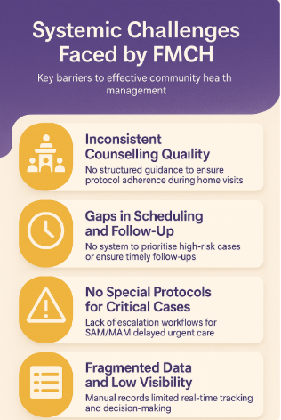
* **No Distinction in Protocols for Critical Cases**: FMCH lacked dedicated workflows or alert systems for malnutrition cases. Without a specific protocol for SAM/MAM, field staff had no way to escalate urgent cases or adjust visit frequency based on severity. This delayed treatment and compromised outcomes for vulnerable children.
* **Fragmented Data and Limited Insights**: Manual data collection led to information silos, inconsistent recordkeeping, and limited visibility into program performance. Managers could not track field productivity, assess compliance with protocols, or use real-time data to make course corrections.

Together, these issues posed a significant barrier to FMCH’s mission: delivering timely, high-quality, and equitable care to every mother and child. The organisation needed a solution that not only digitised field workflows but truly enabled field workers to do their jobs better with greater precision, efficiency, and empathy.

1. Solution Development

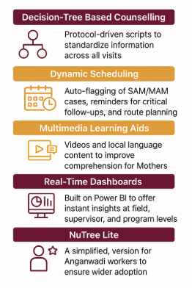

To address these challenges and strengthen service delivery, FMCH developed NuTree, a multilingual mobile application designed to streamline field operations and enhance accountability. The app provided frontline workers with structured, protocol-based counselling workflows, ensuring consistent delivery of health and nutrition information across all visits. Through built-in decision trees and multimedia learning aids, NuTree empowered field officers to tailor communication to each family’s context while maintaining adherence to clinical guidelines.

The platform featured intelligent scheduling tools that prioritised high-risk cases and helped reduce missed visits. Real-time data entry and synchronisation enabled supervisors to monitor progress, review performance, and provide timely support. In addition to its core features, FMCH introduced NuTree Lite, a simplified version tailored for Anganwadi workers, encouraging wider adoption within government systems.

By integrating technology with field-based knowledge, NuTree became a cornerstone of FMCH’s approach to scalable, high-fidelity public health programming.

1. Solution Roll-Out Approach

FMCH rolled out its digital solution in phased releases, each focused-on building functionality while reinforcing field usability and program integrity.

**Phase 1 NuTree V1:** The initial version introduced registration and decision-tree-based counselling protocols. It was piloted with a small group of field officers, with user feedback and UAT guiding refinements before wider adoption.

**Phase 2 SAM/MAM Protocols and Dashboards:** This release added structured workflows for high-risk malnutrition cases and integrated Power BI dashboards for supervisory insights. Revisions were based on field feedback to ensure real-time data use translated into timely interventions.

**Phase 3 NuTree Lite for Anganwadi Workers:** A simplified version was co-developed with ICDS departments to suit public system needs. Tailored for ease of use in low-resource settings, NuTree Lite enabled scale while retaining core functionalities.

At each stage, features were tested, observed, and refined in real conditions. Field teams were actively engaged in shaping functionality, ensuring that each release aligned with actual workflows and capacity. FMCH’s approach demonstrated that digital success lies in listening, iterating, and building with and not just for users.

1. Impact

NuTree significantly enhanced FMCH’s ability to scale nutrition care while improving frontline performance and outcomes for children.

* 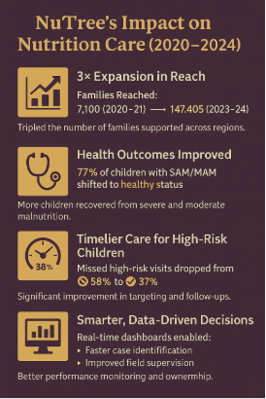
* **Expanded Reach**: 3× increase in families reached; from 7,100 families in 2020–21 to 147,405 families in 2023–24.
* **Improved Health Outcomes**: 77% of SAM/MAM children (Severe/Moderate Acute Malnutrition) moved to the healthy category.
* **Better Targeting and Timeliness**: Missed high-risk visits dropped from 58 percent to 37 percent, enabling more timely care.
* **Smarter Decisions**: Real-time dashboards supported faster identification of cases and improved field supervision.
* **Greater Accountability**: Field teams showed stronger adherence to protocols, leading to a culture of data-driven action.

1. Tech Stack

|  |  |
| --- | --- |
| **Component** | **Description** |
| NuTree App (Android) | Protocol-based workflows, multilingual user interface, and visit tracking |
| NuTree Lite | Simplified version designed for Anganwadi workers |
| Microsoft Power BI | Dashboarding and analytics for field-level and program-level decision-making |
| WhatsApp Integration | Video content sharing and behavioral nudges for community engagement |
| Glific Chatbot | AI-driven, rule-based conversational agent designed to support mother engagement |

1. Key Project Learnings

FMCH’s experience with NuTree highlighted how thoughtfully integrated technology can enhance frontline efficiency, accountability, and sustainability of outcomes:

* **Structured Protocols Enable Prioritisation**: Integrating SAM and MAM guidelines into scheduling allowed field teams to deliver more timely and proactive care.
* **Dashboards Strengthen Daily Practice**: Real-time visual tools evolved into mentoring aids, driving accountability and informed supervision.
* **Digital Inclusion is Achievable:** With the right support, even first-time users like Anganwadi workers adopted digital tools with confidence.
* **Peer-Led Support Sustains Change**: The mother support group pilot demonstrated that community-driven, tech-enabled models can continue to deliver impact beyond NGO involvement.
* **Shift from Outputs to Outcomes**: Composite indicators helped move beyond activity tracking to enable decisions based on real outcomes.

1. Adaptability In the Sector

NuTree’s flexible design and field-tested success make it well-suited for replication across the development ecosystem:

* **Government Systems**   
  Platforms like ICDS, NHM, and POSHAN can integrate similar tools to strengthen frontline delivery and supervision.
* **NGO Field Operations**   
  Organisations can adopt NuTree’s approach to digitise field processes while maintaining a people-first approach.
* **Collaborative Projects**   
  Ideal for multi-partner initiatives requiring shared dashboards, unified data standards, and aligned reporting.

NuTree has not only scaled FMCH’s impact but also offers a replicable blueprint for tech-enabled, community-driven delivery at scale.

# **Case Study 9: Educate Girls (Keyword: Precision Targeting)**

**Thumbnail Header:** Predictive Targeting to Enroll Girls

Headers: Predictive tech to identify and target high-need geographies for out-of-school girl enrolment

## **Quick Facts**

|  |  |
| --- | --- |
| **Category** | **Details** |
| Organisation Name | Educate Girls |
| Organisation Website Link | https://www.educategirls.ngo |
| About the organization | Educate Girls is a non-profit working in India’s rural and educationally backward districts to improve girls’ enrollment, retention, and learning outcomes. It mobilizes communities and leverages public systems to close gender gaps in education. |
| Founding Year | 2007 |
| Number of Beneficiaries served | 1.56 million out-of-school girls enrolled (as of 2023); 18 million+ beneficiaries reached through outreach and engagement |
| Geography Served | Rajasthan, Madhya Pradesh, Uttar Pradesh |
| SDG Alignment | SDG 4: Quality Education  SDG 5: Gender Equality  SDG 10: Reduced Inequalities |
| Focus Area | Programmatic Impact and Operational Efficiency |
| Functions Impacted | Strategic Planning; Expansion Operations; Field Deployment; Monitoring & Evaluation |
| Key Technologies Used | Python, Random Forest ML Algorithm, Census & Public Datasets (DISE, ASER, SECC, SHRUG), Custom Dashboards |

## **Summary**

**Impact numbers**

* **1.56 million** girls enrolled in just 6 years
* **7x faster** impact compared to the previous model
* **90%** model accuracy with major cost and time savings

**About Educate Girls**

Educate Girls is a non-profit working in India’s rural and educationally backward districts to improve girls’ enrollment, retention, and learning outcomes. It mobilizes communities and leverages public systems to close gender gaps in education.

**Problem Statement**

Educate Girls’ saturation-based model ensured full coverage but, as the program scaled, it struggled with efficiency. Field teams spent equal effort across all areas, leading to delayed impact, strained resources, and limited scalability, highlighting the need for a more targeted, data-driven approach.

**Solution**

Development of a machine learning model that used public and survey data to predict village-level need. This enabled the team to prioritize high-need areas, streamline field operations, and shift from blanket outreach to precision targeting, improving scalability without compromising equity**.**

**Learnings**

* Strategic village targeting can exponentially accelerate program reach and cost-efficiency.
* Every model iteration must be grounded in actual field data to ensure reliability.
* Simplifying outputs enabled frontline and expansion teams to use ML insights effectively.
* Using publicly available datasets makes the model portable across states and organizations.

**Key Technologies Used**

* Python
* Random Forest ML Algorithm
* Census & Public Datasets (DISE, ASER, SECC, SHRUG)
* Custom Dashboards

## **Full case study**

1. Problem Statement / Challenges Faced

Educate Girls’ saturation-based approach to identifying out-of-school girls ensured full coverage but lacked efficiency and scalability. Field teams spent equal effort in both high- and low-need areas, delaying impact and straining resources.

With a wealth of household and public data available, the challenge was to shift from blanket coverage todata-driven precision targetingwithout compromising on equity.

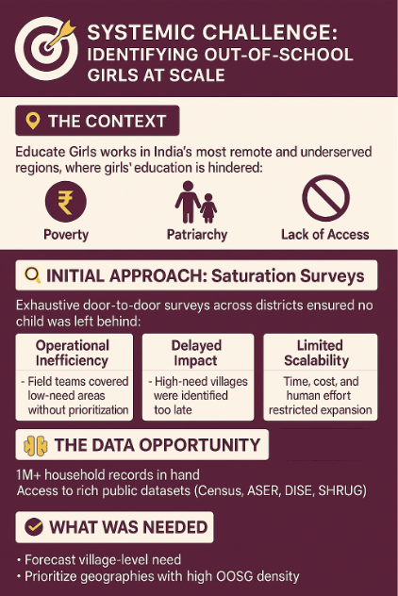

1. Solution Development

Educate Girls partnered with IDinsight to develop a Machine Learning model using the Random Forest algorithm, trained on survey data from 29 districts and enriched with multiple public datasets (Census, DISE, ASER, SECC, SHRUG). The model was designed to:

* Predict village-level concentrations of OOSGs
* Categorize villages into Plans A–D based on need and operational feasibility
* Identify geographic “hotspots” using clustering
* Prioritize interventions using a ranked list of high-need areas

The shift from Strategy 1.0 (saturation) to Strategy 2.0 (data-driven targeting) marked a fundamental evolution in how Educate Girls approached its mission of turning large datasets into actionable, predictive insights.

1. Solution Roll-Out Approach

Educate Girls approached the implementation of its machine learning solution with a clear focus on precision, usability, and scalability. Recognizing the complexity of deploying advanced analytics in rural contexts, the organization adopted a phased strategy that blended cutting-edge technology with field-based validation. At every stage, stakeholder feedback, user testing, and real-world learning shaped the platform’s evolution ensuring the model not only predicted need but was actionable on the ground.

* Phase 1: Initial model development using historical household data and public datasets, tested against known field results.
* Phase 2: Model iterations and validations with live field data to refine accuracy. Prediction accuracy reached 90% over three testing cycles.
* Phase 3: Operational integration with strategic planning. Expansion teams used ranked village lists to deploy interventions.
* Phase 4: Model outputs were simplified for non-technical staff and feedback loops were institutionalized. The model was retrained periodically as new data became available.

The transition was supported by a strong emphasis on user interpretation, ensuring that teams could trust and act on ML insights without needing deep technical knowledge.

1. Impact

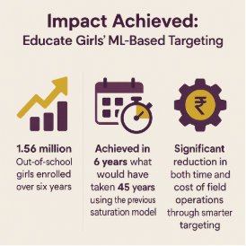

Educate Girls’ adoption of machine learning transformed how outreach was prioritized and scaled, unlocking exponential gains in efficiency and reach.

* 1.56 million out-of-school girls enrolled over 6 years
* Achieved in 6 years what would have taken 45 years under the previous model
* Significant reduction in time and cost for field operation.

1. Tech Stack

|  |  |
| --- | --- |
| **Tool / Platform** | **Purpose** |
| Python | ML model development |
| Random Forest Algorithm | Predictive modeling |
| Census, DISE, ASER, SECC | Public datasets for model training |
| Custom dashboard outputs | Visualization for field use |

1. Key Project Learnings

Educate Girls’ machine learning journey offers practical insights on applying data science in grassroots settings.

* **Targeting is transformative**: Strategic village targeting can exponentially accelerate program reach and cost-efficiency.
* **Field validation is critical:** Every model iteration must be grounded in actual field data to ensure reliability.
* **Democratize tech:** Simplifying outputs enabled frontline and expansion teams to use ML insights effectively.
* **Scalability lies in design:** Using publicly available datasets makes the model portable across states and organizations.

1. Adaptability In the Sector

|  |  |
| --- | --- |
| **Sector** | **How the Solution Can Be Applied** |
| Education | Target regions with low enrollment or high dropout rates using predictive analytics |
| Health | Forecast maternal health risks, malnutrition zones, or immunization gaps |
| Livelihoods | Identify under-skilled populations for targeted vocational training and employment programs |

## **Tools to add**

Python

# 

# Case Study 10: Educate Girls (Keyword: Operational Excellence)

**Thumbnail Header:** GIS-Powered Planning for Field Efficiency

**Header: GIS for Targeted Expansion: Spatial intelligence to identify underserved geographies and optimize resource deployment**

## Quick Facts

|  |  |
| --- | --- |
| **Category** | **Details** |
| Organisation Name | Educate Girls |
| Organisation Website Link | https://www.educategirls.ngo |
| Founding Year | 2007 |
| Number of Beneficiaries served | 1.56 million out-of-school girls enrolled (as of 2023); 18 million+ beneficiaries reached through outreach and engagement |
| Geography Served | Rajasthan, Madhya Pradesh, Uttar Pradesh |
| SDG Alignment | SDG 4: Quality Education  SDG 5: Gender Equality  SDG 10: Reduced Inequalities |
| Focus Area | Programmatic Impact and Strategic Expansion |
| Functions Impacted | Geographic Targeting; Expansion Planning; Field Deployment; Monitoring & Evaluation |

## **Summary**

**Impact numbers**

* **1.56 million** girls enrolled in just 6 years
* **7x faster** impact compared to the previous model
* **90%** model accuracy with major cost and time savings

**About Educate Girls**

Educate Girls is a non-profit working in India’s rural and educationally backward districts to improve girls’ enrollment, retention, and learning outcomes. It mobilizes communities and leverages public systems to close gender gaps in education.

**Problem Statement**

As outreach expanded, on-ground operations became inefficient due to manual planning, redundant travel, uneven workload, and limited oversight—creating a need for a system to streamline daily execution, enhance visibility, and improve staff accountability across large geographies.

**Solution**

A GIS-powered planning tool was developed by integrating spatial data into the mobile MIS, enabling real-time mapping, automated cluster generation, and route optimization. Built with user input and rolled out in phases, the tool empowered field teams with data-driven planning, transparency, and operational efficiency.

**Learnings**

* **Planning became more strategic** with spatial tools enabling equitable, data-driven field coordination.
* **Staff deployment bias reduced** through automated clustering, ensuring fair workload distribution.  
  **Accountability improved** as digital schedules allowed real-time monitoring of planned vs. actual activity.

**Key Technologies Used**

* GIS Software
* Spatial Clustering Models
* Custom Dashboards

## **Full Case study**

**Challenge**

**Manual planning and limited oversight created bottlenecks in daily execution across vast geographies.**

As Educate Girls scaled its outreach, ensuring daily execution efficiency across vast geographies became a major challenge. While strategic targeting helped identify high-need geographies, the on-ground field operations were hindered by manual planning, inefficient travel routes, uneven workload distribution, and limited oversight. There was a pressing need to develop a system that could improve operational coordination, real-time visibility, and staff accountability.

**Solution**

**A spatial intelligence platform streamlined field operations with automated clustering, route optimization, and real-time visibility.**

The development of the GIS-based solution at Educate Girls was a result of deliberate, phased innovation aimed at addressing the execution gap in field operations. The team approached this with three guiding principles: data-driven planning, spatial efficiency, and user-centric design.

1. Leveraging Existing Infrastructure for Location Intelligence: Educate Girls enhanced its existing mobile information system by integrating geospatial intelligence. By formalizing the use of location data from staff attendance and household visits, it built a rich spatial dataset covering villages, households, and schools for future analysis.
2. GIS System Architecture and Data Integration: To enable geospatial mapping, the technical team integrated a QGIS server into the MIS and used shapefiles from Maps of India to map administrative units at the village level. Alignment with ground realities was ensured through internal validation using field-captured coordinates.
3. User Experience and Functional Modules: Educate Girls designed intuitive GIS modules with direct input from field users to ensure relevance and ease of use:

* Coverage View - Visualizes schools and households across geographies
* Heat Map Module - Maps performance indicators spatially for quick insights
* Cluster Generator - Groups villages based on proximity and program needs
* Planning Interface - Helps coordinators prioritize visits using spatial data

All modules were built for scalability, offline use, and cross-level access, enabling district managers, block officers, and field staff to engage with the platform effectively.

1. Embedded Intelligence: The system incorporated logic to prioritize villages and households using factors like OOS girl status, readiness, proximity, and logistical feasibility. This allowed adaptive, nuanced field planning.
2. Solution Roll-Out Approach

Educate Girls adopted a structured, phased rollout to ensure the GIS-based operational planning tool was tested, refined, and scaled effectively across its geographies.

**Phase 1: Pilot Implementation**: The first deployment was conducted in Shahjahanpur district, Uttar Pradesh. The pilot focused on validating three core modules: cluster generation, village-level overlays, and the planning interface for field teams. This phase tested the tool’s usability and its impact on coordination and workload distribution.

**Phase 2: Iterative Refinement through Field Feedback:** Following the pilot, feedback from district officers and field staff informed critical updates. Inputs included the need to accommodate geographic nuances like rivers or poor road access, enable granular household prioritization, and offer flexibility for field disruptions. These insights shaped improvements in the user interface, filters, scoring ranges, and logic.

**Phase 3: Expansion to 17 Districts**: With enhancements in place, the solution was scaled across 17 districts in Uttar Pradesh and Madhya Pradesh. A structured onboarding process ensured readiness at all levels:

* District and block officers received targeted training
* Field coordinators were onboarded through simplified walkthroughs
* Geo-tagged datasets were preloaded to ensure seamless local use

**Phase 4: Gradual Introduction of the Planning Module:** To support adoption among field coordinators, the planning module was introduced more gradually Staff began using it to plan daily visits, prioritize households, and submit schedules in advance. Early signs indicated improved route consistency, reduced manual edits, and greater alignment between planned and actual field activity.

**Impact**

**The solution reduced travel redundancy, balanced workloads, and empowered teams with data-backed execution tools.**

The GIS solution delivered both measurable operational gains and significant shifts in field practice and accountability.

**Quantitative Improvements**

* Enhanced time efficiency by reducing travel redundancies and improving daily route planning
* Achieved consistent field coverage across clusters with equitable distribution of staff workload
* Enabled data-driven central planning with the ability to adjust field plans in real time

**Qualitative Outcomes**

* Replaced manual cluster assignments with objective, location-based logic, removing human bias
* Empowered supervisors with visibility into planned vs. actual activity, improving transparency
* Fostered greater ownership among field teams, reinforcing accountability for coverage and executionTop of FormBottom of Form

1. Tech Stack

|  |  |
| --- | --- |
| **Component** | **Description** |
| Mobile MIS | Offline-first application used by field staff for data collection and operational planning |
| QGIS Server | Geospatial engine used for spatial analysis, mapping, and integration with existing MIS platform |
| Shape Files (Maps of India) | Official administrative boundary data, aligned with ground realities using field-collected GPS |

1. Adaptability In the Sector

|  |  |
| --- | --- |
| **Use Case / Sector** | **How the GIS Model Can Be Applied** |
| Public Health (e.g., Immunisation, Nutrition) | Plan and monitor field staff visits to households based on high-need clusters; track real-time service coverage gaps. |
| WASH (Water, Sanitation & Hygiene) | Identify underserved communities for targeted sanitation or water interventions using geospatial clustering. |
| Agriculture Extension Services | Map and segment farm plots or villages by crop type, risk factors, or support needs; optimize field agent deployment. |
| Livelihoods & Skilling Programs | Cluster rural or urban areas based on unemployment or income data to prioritize outreach and skill-building sessions. |
| Disaster Response & Preparedness | Plan relief operations using real-time spatial data and prioritize vulnerable zones for early response and resource deployment. |
| Education System Strengthening | Identify school-access gaps or low-retention areas to plan cluster-based teacher deployment or infrastructure upgrades. |

# Case Study 11: ARMMAN

**Thumbnail Header: Transforming Last-Mile Health Digitally**

Advancing Reduction in Mortality and Morbidity of Mothers, Children and Neonates

Keyword :Public Health Program Delivery

## **Quick Facts**

|  |  |
| --- | --- |
| **Category** | **Details** |
| Organisation Name | **ARMMAN** |
| Organisation Website Link | https://armman.org/ |
| Founding Year | 2008 |
| Number of Beneficiaries served | 63 million+ across programs (as of 2024); ~11,000+ women and 11000+ newborns through Arogya Sakhi Program. |
| Geography Served | AROGYASAKHI: Maharashtra (Palghar and Nandurbar districts), with potential to scale across rural India |
| SDG Alignment | SDG 3 (Good Health and Well-being), SDG 10 (Reduced Inequalities) |
| Focus Area | Programmatic Impact, Operational Efficiency |
| Functions Impacted | Program Delivery, Beneficiary Services, Monitoring & Evaluation, Donor Reporting |

## **Summary**

**Impact numbers**

* 0 maternal deaths among identified high-risk pregnancies (2023–24) due to digital escalation.
* 90% follow-up for high-risk pregnancies identified by the app.
* 100% digital field data collection achieved by 2021.

**About ARMMAN**

ARMMAN is a non-profit organization leveraging technology to empower mothers, children, and health workers with critical information and services across the continuum of care. Through a public health lens, ARMMAN builds scalable, cost effective digital health solutions to reduce preventable maternal and child mortality and morbidity

**Problem Statement**

Operating in remote tribal regions with poor maternal and neonatal health, ARMMAN's Arogya Sakhi program faced challenges including manual data collection, delayed risk classification, limited real-time visibility, and fragmented referral tracking, hindering scalability and timely interventions.

**Solution**

ARMMAN digitally transformed by equipping Arogya Sakhis with a custom Android app for data capture, automated risk alerts, and referral management. This solution included integrated backend dashboards for real-time visibility, automated decision support, and offline capabilities. Implementation involved a phased, co-created rollout with extensive training and support.

**Learnings**

* Involving ground teams in co-creation is crucial for user acceptance and effective implementation.
* **Offline capabilities are** vital for consistent data collection in low-connectivity areas.
* **Data literacy is key:** Training supervisory teams to interpret and act on data maximizes dashboard value.

**Key Technologies Used**

* Custom Android Mobile Application with built in Dashboards
* Automated MIS
* Digital Risk Stratification

## **Full Case study**

Challenge

**Bridging Critical Gaps in Last-Mile Maternal and Neonatal Care**

ARMMAN's Arogya Sakhi program faced significant hurdles in delivering maternal and neonatal care in remote, tribal regions of Maharashtra. These areas suffered from poor health indicators, weak infrastructure, and limited access to care, compounded by geographical isolation and socio-cultural factors.

* **Manual Data Collection:** Reliance on paper-based forms led to inefficiencies, including delayed risk identification and errors.
* **Lack of Real-time Oversight:** Program managers lacked immediate visibility into field activities and health outcomes.
* **Fragmented Referral Tracking:** Ensuring high-risk cases reached appropriate facilities was challenging due to disconnected tracking.
* **Limited Scalability:** Manual processes and lack of real-time data hindered the program's ability to expand and effectively manage cases.

These issues collectively limited scalability and the timely escalation of high-risk cases, underscoring an urgent need for a robust, digitally-enabled solution.

Solution: **A Data-Driven Digital Transformation for Last-Mile Health**

To address these challenges, ARMMAN initiated a strategic digital transformation, empowering Community Health Workers (CHWs) with mobile-based tools and establishing robust data-driven program oversight.

* **Technology Choices:**
  + Implemented a custom Android mobile application for Arogya Sakhis, enabling real-time data capture, automated risk alerts, and streamlined referral pathways.
  + Ensured critical offline capabilities were integrated into the app for reliable use in low-connectivity rural areas.
  + Developed an integrated backend system with dynamic dashboards to provide real-time data visibility and automated decision support for supervisors and program managers.
* **Implementation Approach:**
  + Executed a phased rollout, co-created with frontline teams to ensure contextual relevance and user adoption.
  + Conducted extensive capacity-building programs for CHWs to enhance digital literacy and application proficiency.
  + Established continuous feedback loops and iterative updates based on field testing and user input.
* **Support & Funding:**
  + Provided dedicated tech support via a helpdesk to address real-time issues and minimize disruptions.
  + Secured funding from various CSR donors (e.g., GEP, Chevron, Kotak Foundation, Citius Tech) and collaborated with strategic tech and evaluation partners.

**Outcomes and Impact**

**Enhanced Reach, Efficiency, and Quality of Care**

The digital transformation profoundly improved the Arogya Sakhi program's reach, operational efficiency, and quality of maternal and neonatal care.

* **Zero maternal deaths** among identified high-risk pregnancies since digital escalation protocols were introduced (2023–24).
* **90% follow-up** for high-risk cases identified by the app.
* **100% digital field data collection** achieved by 2021, leading to enhanced data quality and real-time visibility for supervisors.
* **Reduced CHW paperwork**, increasing time for direct beneficiary engagement and counselling.
* **Improved donor transparency** through data-backed reporting.
* **Optimized resource allocation** via better referral mechanisms.
* **Embedded data-driven decision-making** within operations.
* **Solidified ARMMAN's credibility** as a model for last-mile service delivery.

## Snapshots

